Hermes Transport
Courier Services Management and Tracking Platform

Technical Guide


Table of contents
Intro 3
Prerequisite Programs and Software 3
Links to software 4
Configure PHP 24
Cloning the Project 26
Install Dependencies 28
Configure the Environment 28
Build and seed the database 28
Start the App 29

Introduction

Purpose
The purpose of Hermes transportation Platform, the ParcelManagement Platform, is to streamline and digitize the management of parcel deliveries and collections for residents at the North-West University (NWU) across all campuses. The platform provides a centralized, secure, and role-based system that allows the tracking of parcels as they arrive at the campus until they are delivered to the respective resident, tracking the parcels details, courier details and sending out automatic notification to streamline the process.
By transitioning from manual or fragmented processes to a unified digital solution, Hermes Transportation platform aims to enhance efficiency and accountability in parcel delivery. In addition to meeting NWU’s operational requirements, the platform is designed with scalability and modularity in mind—allowing for future commercialization.

Scope
Hermes Transportation Platform is being developed as a Minimum Viable Product (MVP) that fulfils NWU’s immediate needs while laying the foundation for future expansion. The MVP will incorporate core functionality centred around parcel tracking, data security, and administrative efficiency, including:
• User Authentication and Role Management: Secure login and access control compliant with POPIA data protection standards, these roles being the administrative user and normal staff user.
• Parcel creation and tracking: Creating the parcels when they arrive at the campus and tracking the status of whether the parcel has been collected or not
• Courier Management: Creation and coordination couriers who deliver parcels to the campus.
• Notification System: automated messages sent out when parcels are created and the ability to review the history of these messages.
• Financial reports: the ability to consolidate parcel collections into a single downloadable report based on a specified range.
The system architecture is designed to be scalable and modular, supporting integration with future components such as the NWU Student Information System (SIS) and advanced analytics dashboards. This approach ensures that Hermes Transportation Platform remains adaptable for long-term institutional needs and potential commercial deployment.

System Setup

Pre-requisites

Category | Requirement | Description
Operating  System | Windows 10/11 | Developer-compatible environment
Package  Managers | Composer ≥ 2.7, Node.js v22 + npm 10 + Yarn ≥ 1.22 | Required for installing Laravel /  React dependencies
Source Control | Git ≥ 2.40 | Version-control system for cloning and managing source code
Browser | Chrome, Edge, or Firefox  (latest) | For accessing the web interface
Database | PHP sqllite | Used by Laravel for persistence

System Architecture

Overview
The Parcel Management Platform, named Hermes Transportation Platform, was developed using a three-tier web architecture consisting of a presentation layer (frontend), an application layer (backend), and a data layer (database). This layered structure ensures scalability, maintainability, and clear separation of concerns, making it easier to extend the platform beyond the semester’s MVP phase. This architecture combines React.js, Laravel, and PHP, forming a secure, fast, and modern web application framework suited for academic and production environments.

Presentation Layer (Frontend)

Overview
The Hermes Platform frontend is built as a modern, responsive Single-Page Application (SPA) using React 19 and TypeScript, seamlessly connected to the Laravel backend via Inertia.js. This setup allows the backend to send data directly to the frontend without needing a separate API layer. This results in faster page loads, less network traffic, and a smoother experience without full page reloads.
The platform is explicitly optimized for desktop and laptop environments, serving as a comprehensive management dashboard for Administrators and Staff (with dedicated operational views for roles such as Couriers). The interface prioritizes clear data visualization, advanced table filtering, and streamlined workflow management (e.g., Parcel tracking, Financial Reports, and Staff coordination).
Key characteristics of the Hermes Platform presentation layer include:
● Reusable Components: We build the interface using shared, pre-made UI pieces (like buttons, forms, and tables) so everything looks and works consistently across the platform.
● Fast Development Tools: We use Vite to make the site load instantly while we build it, and to create fast, efficient final versions for everyday use.
● Consistent Styling: We use Tailwind CSS to keep the design clean, support dark mode, and build expansive desktop dashboards quickly.
● Clear Data Charts: We use Recharts to turn complex operational data into easy-to-read graphs and charts for the admin dashboards.
● Fewer Coding Errors: We use TypeScript to catch mistakes early in the development process, making the system more reliable and easier for the team to maintain.
● Role-Based Layouts: The screen layout (like the sidebar and header) automatically adjusts to show only the tools an Admin or Staff member needs, keeping the desktop view organized and clutter-free.

Technology Stack
The Hermes Platform uses a modern set of tools to ensure the desktop dashboard is fast, reliable, and easy for the development team to maintain. Below is a breakdown of the core technologies used to build the frontend.
● Core Framework: React 19 and TypeScript for building the user interface with strict error checking.
● Application Bridge: Inertia.js and Vite to connect the React frontend with the Laravel backend smoothly.
● Styling & Design: Tailwind CSS v4, Radix UI, and Headless UI to create a clean, consistent, and accessible desktop layout.
● Data Visualization: Recharts to display operational data, financial reports, and analytics in easy-to-read graphs.
● Utilities: Lucide React for icons, and tools like html5-qrcode and react-barcode for scanning and tracking parcels.
Below is the configuration file (package.json) that manages these tools and their specific versions:
{
"dependencies": {
"@headlessui/react": "^2.2.0",
"@inertiajs/react": "^2.0.0",
"@radix-ui/react-avatar": "^1.1.3",
"@radix-ui/react-dialog": "^1.1.6",
"@radix-ui/react-dropdown-menu": "^2.1.6",
"@radix-ui/react-select": "^2.1.6",
"@tailwindcss/vite": "^4.1.11",
"class-variance-authority": "^0.7.1",
"clsx": "^2.1.1",
"html5-qrcode": "^2.3.8",
"laravel-vite-plugin": "^2.0",
"lucide-react": "^0.475.0",
"react": "^19.0.0",
"react-barcode": "^1.6.1",
"react-dom": "^19.0.0",
"recharts": "^3.10.1",
"tailwind-merge": "^3.0.1",
"tailwindcss": "^4.0.0",
"typescript": "^5.7.2",
"vite": "^7.0.4"
}
}
Physical Code Explanation:
● Lines 3-4: @headlessui/react and @inertiajs/react bring in pre-built, accessible UI components and the bridge that connects our React frontend to the Laravel backend.
● Lines 5-8: The @radix-ui packages provide the building blocks for complex desktop UI elements like dropdown menus, dialog pop-ups, and data selection tools.
● Lines 9-10: @tailwindcss/vite and class-variance-authority help manage our styling, ensuring buttons and components look consistent and adapt correctly to different screen sizes.
● Lines 11-12: clsx and html5-qrcode are utility tools. clsx helps cleanly apply CSS classes, while html5-qrcode allows staff to scan parcel barcodes directly from their laptop webcams.
● Lines 13-16: laravel-vite-plugin, lucide-react, react, and react-barcode handle the core application setup, provide clean icons, run the main React library, and generate barcode visuals for parcels.
● Lines 17-21: recharts, tailwind-merge, tailwindcss, typescript, and vite power the data charts for the admin dashboard, manage our CSS utility classes, enforce strict coding rules, and build the final application quickly.

Frontend Architecture
The Hermes Platform uses Inertia.js to bridge the gap between the Laravel backend (PHP) and the React frontend (TypeScript). This architecture allows us to build a modern Single-Page Application (SPA) without the complexity of building a separate API for every page.
How It Works: Instead of the React frontend fetching data from an API endpoint (like GET /api/users) to build a page, the Laravel controller sends the data directly to the React component as "props."
- User Action: A user clicks a link or submits a form.
- Inertia Intercepts: Inertia catches the request and sends it to the Laravel backend via XHR (Ajax).
- Laravel Response: The Laravel controller processes the logic and returns an Inertia response containing the name of the React component to render and the data (props) it needs.
- React Update: Inertia receives this response and swaps the current React component with the new one, passing the data along. The page updates instantly without a full browser reload.
This approach keeps the code simple and organized, as the backend and frontend stay closely synchronized.
The Entry Point (app.tsx) The file resources/js/app.tsx is the starting point for the entire frontend. It tells the browser how to load the React pages and connect them to the data sent by Laravel.
import { createInertiaApp } from '@inertiajs/react';
import { resolvePageComponent } from 'laravel-vite-plugin/inertia-helpers';
import { createRoot } from 'react-dom/client';

const appName = import.meta.env.VITE_APP_NAME || 'Laravel';

createInertiaApp({
title: (title) => title ? `${title} - ${appName}` : appName,
resolve: (name) => resolvePageComponent(`./pages/${name}.tsx`, import.meta.glob('./pages/**/*.tsx')),
setup({ el, App, props }) {
const root = createRoot(el);
root.render(<App {...props} />);
},
progress: {
color: '#4B5563',
},
});
Physical Code Explanation:
● Lines 1-3: These lines import the necessary tools. createInertiaApp sets up the connection between Laravel and React. resolvePageComponent helps find the correct React file (like Dashboard.tsx) based on the route. createRoot is the standard React way to attach the app to the HTML page.
● Line 5: This sets the default browser tab title (e.g., "Dashboard - Hermes Platform").
● Lines 7-17: This is the core setup function.
o title: Automatically formats the browser tab title for every page.
o resolve: This is the magic link. It looks at the folder ./pages/ and matches the route name to a file (e.g., route dashboard matches pages/Dashboard.tsx).
o setup: This actually renders the React app into the HTML element (el) provided by Laravel, passing the data (props) sent from the backend.
o progress: This configures the small loading bar that appears at the top of the screen when moving between pages.

Role-Based UI
The Two User Roles
The Hermes Platform has two user roles: Administrator and Staff. Both roles sign in through the same authentication pages and arrive at the same dashboard entry point. The difference is which parts of the system they can open and which actions they can perform.
Couriers are a managed part of the system (courier records and assignments), rather than a third login role.
The Screen Areas
The frontend is divided into the following areas. These folders are present in the repository:
Screen Area | Location in the Project | Purpose
Dashboard | pages/Dashboard.tsx | Main overview of platform activity
Parcels | pages/Parcels/ | Parcel records, status and tracking
Couriers | pages/Couriers/ | Courier records and related details
Staff | pages/Staff/ | Staff accounts and management
Financial Reports | pages/FinancialReports/ | Financial overview and reporting
Notifications | pages/Notifications/ | System notices and updates
Settings | pages/settings/ | Profile, password and display preferences
Authentication | pages/auth/ | Sign in, registration and password reset

How Access Is Controlled
Role checking happens in two places, and both are necessary:
- On the server. Laravel checks the user's role before returning a page. If a Staff member tries to open an Admin-only screen by typing the URL directly, the server refuses the request. Hiding a link is not enough on its own.
- In the interface. The logged-in user's details are passed to React as props. The sidebar and navigation use those details to decide which links to show, so each role sees a menu suited to their work.
The practical result is that an Administrator works from a fuller menu, while a Staff member sees a shorter menu focused on daily parcel operations. This keeps the desktop screen uncluttered and reduces the chance of someone opening a screen they cannot act on.
Where the Role Shows in the Layout
The role-aware behaviour is delivered through shared layout components rather than being rewritten on every page:
● app-shell.tsx — Provides the overall frame: header, sidebar and content area. This frame stays in place while the user moves between screens.
● app-sidebar.tsx and nav-main.tsx — Hold the main navigation. These are the components that change according to the user's role.
● nav-user.tsx and user-menu-content.tsx — Show who is signed in and provide access to settings and sign out.
● breadcrumbs.tsx — Shows the user where they are within the platform, which matters on a large dashboard with several nested screens.
Because these components are shared, a change to the navigation or layout applies consistently across the whole platform instead of needing to be repeated page by page.
Code Example: Passing the Role to the Frontend
The file app/Http/Middleware/HandleInertiaRequests.php is responsible for sharing global data with the React frontend. It ensures that every page load knows who the user is and what their role is.
public function share(Request $request): array
{
$user = $request->user();

return [
...parent::share($request),
'name' => config('app.name'),
'auth' => [
'user' => $request->user()
? [
'staff_id' => $request->user()->staff_id,
'name' => $request->user()->name,
'surname' => $request->user()->surname,
'role' => $request->user()->role, // <-- The user's role is passed here
'email_account' => $request->user()->email_account,
]
: null,
],
// ... other shared data like 'ziggy' and 'sidebarOpen'
];
}
Plain-English Explanation:
● Line 3: Gets the currently logged-in user from the request.
● Lines 7-16: Creates an auth object that is sent to every React page. If a user is logged in, it includes their staff_id, name, surname, email_account, and crucially, their role. If no one is logged in, it safely returns null.
Code Example: Enforcing the Role on the Server
The file app/Http/Middleware/EnsureStaffHasRole.php is attached to sensitive routes (like the Staff management pages) to block unauthorized access.
class EnsureStaffHasRole
{
public function handle(Request $request, Closure $next,string...$roles): Response
{
$staff = $request->user();

if (! $staff||!in_{a}rray($staff->role, $roles, true)) {
abort(403, 'You do not have permission to access this page.');
}

return $next($request);
}
}
Plain-English Explanation:
● Line 3: The middleware accepts a list of allowed roles (for example, admin).
● Line 5: It grabs the logged-in user.
● Lines 7-9: It checks if the user exists AND if their role matches one of the allowed roles. If not, it immediately stops the request and shows a "403 Forbidden" error.
● Line 11: If the check passes, it allows the request to continue to the page.
Code Example: Rendering the Navigation
The file resources/js/components/nav-main.tsx handles drawing the sidebar menu links. It uses Inertia's usePage() hook to read the data shared by the backend.
import { SidebarGroup, SidebarGroupLabel, SidebarMenu, SidebarMenuButton, SidebarMenuItem } from '@/components/ui/sidebar';
import { type NavItem } from '@/types';
import { Link, usePage } from '@inertiajs/react';

export function NavMain({ items = [] }: { items: NavItem[] }) {
const page = usePage();

return (
<SidebarGroup className="px-2 py-0">
<SidebarGroupLabel>Platform</SidebarGroupLabel>
<SidebarMenu>
{items.map((item) => (
<SidebarMenuItem key={item.title}>
<SidebarMenuButton asChild isActive={page.url.startsWith(item.href)} tooltip={{ children: item.title }}>
<Link href={item.href} prefetch>
{item.icon && <item.icon />}
<span>{item.title}</span>
</Link>
</SidebarMenuButton>
</SidebarMenuItem>
))}
</SidebarMenu>
</SidebarGroup>
);
}
Plain-English Explanation:
● Line 6: usePage() is an Inertia hook that gives the React component access to all the data shared by Laravel (including the user's role from the previous example).
● Line 12: It loops through an array of items (the menu links) passed to it.
● Line 14: isActive={page.url.startsWith(item.href)} automatically highlights the menu button if the user is currently on that page.
● Lines 15-18: It renders a clickable link with an icon and a title. The actual filtering of which items are passed into this component (e.g., hiding "Staff" from regular Staff users) is handled by the parent layout component before this menu is drawn.

Application Layer
The Application Layer handles incoming requests and the application workflows behind them. In this project, it includes controllers, form requests, middleware, authentication/API access, route definitions, mail workflows, and reporting logic.

Controllers
Controllers connect HTTP routes to business logic. They call models and form requests, coordinate actions, and return rendered pages, redirects, or API responses.

Controller base
app/Http/Controllers/Controller.php
Base class inherited by the application controllers.
<?php

namespace App\Http\Controllers;

abstract class Controller
{
//
}

CourierController
app/Http/Controllers/CourierController.php
Handles courier listing, creation, viewing, editing, updating, and deletion. Uses courier models and form requests and returns Inertia pages or a JSON response.
<?php

namespace App\Http\Controllers;

use App\Models\Courier;
use App\Http\Requests\StoreCourierRequest;
use App\Http\Requests\UpdateCourierRequest;
use Inertia\Inertia;

class CourierController extends Controller
{
public function index()
{
return Inertia::render('Couriers/Index', [
'title' => 'Couriers',
'couriers' => Courier::withCount('parcels')->orderBy('name')->get(),
]);
}

public function create()
{
return Inertia::render('Couriers/Create', ['title' => 'Add Courier']);
}

public function store(StoreCourierRequest $request)
{
$courier=Courier::create($request->validated());

if ($request->wantsJson()) {
return response()->json($courier, 201);
}

return redirect()->route('couriers.index')->with('success', 'Courier added.');
}

public function show(Courier $courier)
{
return Inertia::render('Couriers/Show', [
'title' => 'Courier Details',
'courier' => $courier->load('parcels'),
]);
}

public function edit(Courier $courier)
{
return Inertia::render('Couriers/Edit', [
'title' => 'Edit Courier',
'courier' => $courier,
]);
}

public function update(UpdateCourierRequest $request, Courier $courier)
{
$courier->update($request->validated());

return redirect()->route('couriers.index')->with('success', 'Courier updated.');
}

public function destroy(Courier $courier)
{
$courier->delete();

return redirect()->route('couriers.index')->with('success', 'Courier removed.');
}
}

DashboardController
app/Http/Controllers/DashboardController.php
Prepares dashboard metrics, a seven-day parcel chart, recent parcel records, and the collection forecast.
<?php

namespace App\Http\Controllers;

use App\Models\Parcel;
use Carbon\Carbon;
use Inertia\Inertia;

class DashboardController extends Controller
{
public function index()
{
// Existing Stats
$totalParcels = Parcel::count();
$receivedCount = Parcel::where('status', 'received')->count();
$collectedCount = Parcel::where('status', 'collected')->count();

// Existing Chart Data (Last 7 Days)
$chartData = [];
for ($i = 6; $i >= 0; $i--) {
$date=Carbon::now()->subDays($i)->format('Y-m-d');
$label=Carbon::now()->subDays($i)->format('M d');

$received = Parcel::whereDate('date_received', $date)->count();
$collected = Parcel::where('status', 'collected')
->whereDate('date_collected', $date)
->count();

$chartData[] = [
'date' => $label,
'received' => $received,
'collected' => $collected,
];
}

// Existing Recent Parcels
$recentParcels = Parcel::with('courier')
->orderBy('date_received', 'desc')
->take(5)
->get(['parcel_id', 'tracking_number', 'status', 'recipient_name', 'date_received']);

// NEW: Generate Collection Forecast (SQLite Compatible)
$collectionForecast = $this->generateCollectionForecast();

return Inertia::render('Dashboard/Index', [
'title' => 'Dashboard',
'totalParcels' => $totalParcels,
'receivedCount' => $receivedCount,
'collectedCount' => $collectedCount,
'chartData' => $chartData,
'recentParcels' => $recentParcels,
'collectionForecast' => $collectionForecast,
]);
}

/**
* DSS Logic: Predicts collection volume for next 7 days
* Uses PHP Carbon instead of SQL DAYNAME() for SQLite compatibility
*/
private function generateCollectionForecast(): array
{
// Get all collected parcels from last 30 days
$parcels = Parcel::where('status', 'collected')
->whereNotNull('date_collected')
->whereBetween('date_collected', [
Carbon::now()->subDays(30),
Carbon::now()
])
->get(['date_collected']);

// Group by day of week using PHP
$dayCounts = [];
foreach ($parcels as $parcel) {
$dayName=Carbon::parse($parcel->date_collected)->format('l'); // e.g., "Monday"
if (!isset($dayCounts[$dayName])) {
$dayCounts[$dayName] = 0;
}
$dayCounts[$dayName]++;
}

// Calculate averages (approx 4.3 weeks in 30 days)
$dayAverages = [];
foreach ($dayCounts as $day => $count) {
$dayAverages[$day] = $count / 4.3;
}

$forecast = [];
$today = Carbon::now();

// Find overall average to determine "peak" threshold
$overallAvg=!empty($dayAverages) ? array_sum($dayAverages)/count($dayAverages) : 0;
$peakThreshold = $overallAvg * 1.2; // 20% above average is a peak

for ($i = 0; $i < 7; $i++) {
$date = $today->copy()->addDays($i);
$dayName = $date->format('l');

// Base prediction from historical average
$basePrediction = $dayAverages[$dayName] ?? 0;

// Simple trend adjustment
$adjustment=match($date->dayOfWeek) {
0, 6 => 1.05, // Weekend slight boost
1 => 0.95, // Monday slight dip
default => 1.0
};

$predicted=max(0,round($basePrediction * $adjustment));

$forecast[] = [
'date' => $date->format('M d'),
'day_name' => $dayName,
'predicted_collections' => $predicted,
'is_peak' => $predicted > $peakThreshold && $overallAvg > 0,
'confidence' => min(95, 65 + ($i * 4)),
];
}

return $forecast;
}
}

FinancialReportController
app/Http/Controllers/FinancialReportController.php
Filters financial data, calculates parcel collection revenue, and prepares reporting/PDF output.
<?php

namespace App\Http\Controllers;

use App\Models\Parcel;
use Illuminate\Http\Request;
use Inertia\Inertia;
use Carbon\Carbon;
use Barryvdh\DomPDF\Facade\Pdf;

class FinancialReportController extends Controller
{
private const DEFAULT_COLLECTION_FEE = 10.00;

private function buildReport(Request $request): array
{
$filter = $request->input('filter', 'monthly');
$search = $request->input('search', '');

if ($filter === 'custom' && $request->filled(['start_date', 'end_date'])) {
$startDate=Carbon::parse($request->input('start_date'))->startOfDay();
$endDate=Carbon::parse($request->input('end_date'))->endOfDay();
} else {
switch ($filter) {
case 'daily':
$startDate = Carbon::now()->startOfDay();
$endDate = Carbon::now()->endOfDay();
break;
case 'quarterly':
$startDate = Carbon::now()->subMonths(2)->startOfMonth();
$endDate = Carbon::now()->endOfMonth();
break;
case 'biannual':
$startDate = Carbon::now()->subMonths(5)->startOfMonth();
$endDate = Carbon::now()->endOfMonth();
break;
case 'annually':
$startDate = Carbon::now()->subMonths(11)->startOfMonth();
$endDate = Carbon::now()->endOfMonth();
break;
case 'monthly':
default:
$filter = 'monthly';
$startDate = Carbon::now()->startOfMonth();
$endDate = Carbon::now()->endOfMonth();
break;
}
}

$query = Parcel::where('status', 'collected')
->whereBetween('date_collected', [$startDate, $endDate]);

if (!empty($search)) {
$query->where(function($q) use ($search) {
$q->where('tracking_number', 'like', "%{$search}%")
->orWhere('recipient_name', 'like', "%{$search}%");
});
}

$parcels = $query->orderBy('date_collected', 'desc')->get();

$collectedCount = $parcels->count();

// FIX: Calculate actual revenue from the database instead of hardcoding
$totalRevenue = $parcels->sum('collection_fee');
$feePerParcel = $collectedCount>0?($totalRevenue / $collectedCount) : self::DEFAULT_COLLECTION_FEE;

return [
'parcels' => $parcels,
'totalRevenue' => $totalRevenue,
'collectedCount' => $collectedCount,
'feePerParcel' => $feePerParcel,
'filter' => $filter,
'search' => $search,
'startDate' => $startDate->toDateString(),
'endDate' => $endDate->toDateString(),
];
}

public function index(Request $request)
{
return Inertia::render('FinancialReports/Index', $this->buildReport($request));
}

public function exportPdf(Request $request)
{
$report = $this->buildReport($request);
$report['filter']=ucfirst($report['filter']);
$report['dateGenerated'] = Carbon::now()->format('Y-m-d H:i:s');

$pdf = Pdf::loadView('pdf.financial-report', $report);

return $pdf->download('financial-report-' . $request->input('filter', 'monthly') . '-' . date('Y-m-d') . '.pdf');
}
}

ParcelController
app/Http/Controllers/ParcelController.php
Handles parcel CRUD, validation, search/details, tracking lookup, status workflows, and parcel-ready notifications.
<?php

namespace App\Http\Controllers;

use App\Http\Requests\StoreParcelRequest;
use App\Http\Requests\UpdateParcelRequest;
use App\Mail\ParcelReadyForCollection;
use App\Models\Courier;
use App\Models\Notification;
use App\Models\Parcel;
use Illuminate\Http\Request;
use Illuminate\Support\Facades\Auth;
use Illuminate\Support\Facades\Mail;
use Inertia\Inertia;

class ParcelController extends Controller
{
public function index(Request $request)
{
$query = Parcel::with(['courier', 'staff'])
->latest('created_at');

if ($request->filled('search')) {
$search = $request->search;

$query->where(function($q) use ($search) {
$q->where('tracking_number', 'like', "%{$search}%")
->orWhere('recipient_name', 'like', "%{$search}%");
});
}

$parcels = $query->get();

return Inertia::render('Parcels/Index', [
'parcels' => $parcels,
'couriers' => Courier::all(),
'filters' => [
'search' => $request->search,
],
]);
}

public function create()
{
return Inertia::render('Parcels/Create', [
'couriers' => Courier::all(),
]);
}

public function store(StoreParcelRequest $request)
{
$validated = $request->validated();

$sendEmail = $request->boolean('send_email');
unset($validated['send_email']);

$validated['staff_id'] = Auth::id();
$validated['collection_fee'] = 10.00;
$validated['date_received'] = now()->toDateString();
$validated['status'] = $validated['status'] ?? 'received';

$parcel=Parcel::create($validated);

if ($sendEmail\&\&!empty($parcel->recipient_email)) {
$notification = Notification::create([
'parcel_id' => $parcel->parcel_id,
'channel' => 'email',
'message' => "Hi {$parcel->recipient_name}, your parcel ({$parcel->tracking_number}) is ready for collection.",
'status' => 'pending',
]);

try {
Mail::to($parcel->recipient_{e}mail)->send(newParcelReadyForCollection($parcel));

$notification->update(['status' => 'sent', 'sent_at' => now()]);
} catch (\Throwable $e) {
report($e);

$notification->update(['status' => 'failed']);
}
}

return redirect()
->route('parcels.index')
->with('success', 'Parcel created successfully.');
}

public function show(Parcel $parcel){
$parcel->load(['courier', 'staff', 'notifications']);
return Inertia::render('Parcels/Show', [
'parcel' => $parcel,
'title' => 'Parcel Details',
]);
}

public function edit(Parcel $parcel)
{
return Inertia::render('Parcels/Edit', [
'parcel' => $parcel,
'couriers' => Courier::all(),
]);
}

public function update(UpdateParcelRequest $request, Parcel $parcel)
{
$validated = $request->validated();

if ($validated['status']==='collected'\&\&!$parcel->date_collected) {
$validated['date_collected'] = now()->toDateString();
}

$parcel->update($validated);

return redirect()
->route('parcels.index')
->with('success', 'Parcel updated successfully.');
}

public function destroy(Parcel $parcel)
{
$parcel->delete();

return redirect()
->route('parcels.index')
->with('success', 'Parcel deleted successfully.');
}

public function apiLookup(Request $request)
{
$request->validate(['tracking_number' => ['required', 'string']]);

$parcel = Parcel::with('courier:courier_id,name')
->where('tracking_number', $request->string('tracking_number'))
->first();

return response()->json([
'found' => (bool) $parcel,
'parcel' => $parcel,
]);
}
}

NotificationController
app/Http/Controllers/NotificationController.php
Handles notification history and workflows such as resending emails and marking parcels collected.
<?php

namespace App\Http\Controllers;

use Illuminate\Support\Facades\Log;
use App\Mail\ParcelCollected;
use App\Mail\ParcelReadyForCollection;
use App\Models\Notification;
use Illuminate\Support\Facades\Mail;
use Inertia\Inertia;

class NotificationController extends Controller
{
/**
* Display all notifications.
*/
public function index()
{
$notifications = Notification::with(
'parcel:parcel_id,tracking_number,recipient_name,recipient_email,date_collected,status'
)
->orderByDesc('created_at')
->paginate(20);

return Inertia::render('Notifications/Index', [
'title' => 'Notifications',
'notifications' => $notifications,
]);
}

/**
* Display successfully sent message history.
*/
public function history()
{
$messages = Notification::with(
'parcel:parcel_id,tracking_number,recipient_name,recipient_email,status,date_collected'
)
->whereIn('status', ['sent', 'delivered'])
->orderByDesc('sent_at')
->paginate(20);

return Inertia::render('Notifications/History', [
'title' => 'Message History',
'messages' => $messages,
]);
}

/**
* Display a single notification.
*/
public function show(Notification $notification) // You're listening to Radio New Vegas, your little jukebox in the Mojave Wasteland. I'm Mr. New Vegas, and I'm here for you.
{
$notification->load('parcel');

return Inertia::render('Notifications/Show', [
'title' => 'Notification Detail',
'notification' => $notification,
]);
}

/**
* Resend the notification email.
*/
public function resend(Notification $notification)
{
$notification->load('parcel');

if (!$notification->parcel) {
return back()->with(
'error',
'The parcel associated with this notification could not be found.'
);
}

if (empty($notification->parcel->recipient_email)) {
return back()->with(
'error',
'This parcel does not have a recipient email address.'
);
}

try {
/*
* If this is the collection notification,
* resend the collection confirmation email.
*/
if (
$notification->message ===
'Your parcel has been collected. Thank you for doing business with us.'
) {
Mail::to($notification->parcel->recipient_email)
->send(
new ParcelCollected($notification->parcel)
);
} else {
/*
* Otherwise, resend the ready-for-collection email.
*/
Mail::to($notification->parcel->recipient_email)
->send(
new ParcelReadyForCollection($notification->parcel)
);
}

$notification->update([
'status' => 'sent',
'sent_at' => now(),
]);

return back()->with(
'success',
'Notification email sent successfully.'
);
} catch (\Throwable $e) {
$notification->update([
'status' => 'failed',
]);

return back()->with(
'error',
'Failed to send notification email.'
);
}
}

/**
* Mark the parcel as collected and send
* a collection confirmation email.
*/
public function markCollected(Notification $notification)
{
$notification->load('parcel');

if (!$notification->parcel) {
return back()->with(
'error',
'The parcel associated with this notification could not be found.'
);
}

$parcel = $notification->parcel;

/*
* Check if the parcel has already been collected.
*/
if ($parcel->status === 'collected') {
return back()->with(
'error',
'This parcel has already been marked as collected.'
);
}

/*
* Update the parcel.
*/
$parcel->update([
'status' => 'collected',
'date_collected' => now()->toDateString(),
]);

/*
* Send the collection confirmation email
* if the parcel has an email address.
*/
if (!empty($parcel->recipient_email)) {
try {
Mail::to($parcel->recipient_email)
->send(
new ParcelCollected($parcel)
);

/*
* Create a NEW notification record for
* the collection email.
*/
Notification::create([
'parcel_id' => $parcel->parcel_id,
'channel' => 'email',
'message' => 'Your parcel has been collected. Thank you for doing business with us.',
'status' => 'sent',
'sent_at' => now(),
]);
} catch (\Throwable $e) {
/*
* Record the actual email error in Laravel's log.
*/
\Illuminate\Support\Facades\Log::error(
'Hermes ParcelCollected email failed',
[
'parcel_id' => $parcel->parcel_id,
'recipient_email' => $parcel->recipient_email,
'exception' => $e->getMessage(),
]
);

/*
* Record the failed collection email notification.
*/
Notification::create([
'parcel_id' => $parcel->parcel_id,
'channel' => 'email',
'message' => 'Your parcel has been collected. Thank you for doing business with us.',
'status' => 'failed',
'sent_at' => null,
]);

return back()->with(
'error',
'Parcel was marked as collected, but the collection email could not be sent.'
);
}

}

/*
* No recipient email was provided.
*/
if (empty($parcel->recipient_email)) {
return back()->with(
'success',
'Parcel marked as collected. No recipient email address was available.'
);
}

return back()->with(
'success',
'Parcel marked as collected and collection email sent successfully.'
);
}
}

SettingsController
app/Http/Controllers/SettingsController.php
Reads and updates the application settings and relevant staff profile/settings values.
<?php

namespace App\Http\Controllers;

use App\Models\Setting;
use Illuminate\Http\Request;
use Illuminate\Support\Facades\Auth;
use Illuminate\Validation\Rule;

class SettingsController extends Controller
{
/**
* Display the settings index page with the authenticated user's data and current settings.
*/
public function index()
{
// Fetch all settings from the database as a simple key-value array
$settings = Setting::pluck('value', 'key')->toArray();

return inertia('settings/Index', [
'user' => Auth::user(),
'settings' => $settings,
]);
}

/**
* Update the user's profile information.
*/
public function updateProfile(Request $request)
{
$user = Auth::user();

$validated = $request->validate([
'name' => ['required', 'string', 'max:255'],
'surname' => ['required', 'string', 'max:255'],
'email_account' => [
'required',
'email',
'max:255',
Rule::unique('staff', 'email_account')->ignore($user->staff_id, 'staff_id')
],
]);

$user->update($validated);

return back()->with('success', 'Profile updated successfully.');
}

/**
* Update application-level settings.
*/
public function updateApplication(Request $request)
{
$validated = $request->validate([
'companyName' => ['required', 'string', 'max:255'],
'contactEmail' => ['required', 'email', 'max:255'],
'contactPhone' => ['required', 'string', 'max:50'],
'address' => ['required', 'string', 'max:500'],
]);

// Save each setting to the database using updateOrCreate
Setting::updateOrCreate(['key' => 'companyName'], ['value' => $validated['companyName']]);
Setting::updateOrCreate(['key' => 'contactEmail'], ['value' => $validated['contactEmail']]);
Setting::updateOrCreate(['key' => 'contactPhone'], ['value' => $validated['contactPhone']]);
Setting::updateOrCreate(['key' => 'address'], ['value' => $validated['address']]);

return back()->with('success', 'Application settings saved.');
}

/**
* Update parcel configuration settings.
*/
public function updateParcel(Request $request)
{
$validated = $request->validate([
'autoTrackingNumber' => ['required', 'boolean'],
'trackingPrefix' => ['required', 'string', 'max:10'],
]);

// Save each setting to the database
Setting::updateOrCreate(['key' => 'autoTrackingNumber'], ['value' => $validated['autoTrackingNumber'] ? '1' : '0']);
Setting::updateOrCreate(['key' => 'trackingPrefix'], ['value' => $validated['trackingPrefix']]);

return back()->with('success', 'Parcel configuration saved.');
}
}

StaffController
app/Http/Controllers/StaffController.php
Manages staff accounts and includes API token issuing/revoking workflows.
<?php

namespace App\Http\Controllers;

use App\Models\Staff;
use Illuminate\Http\Request;
use Illuminate\Validation\Rule;
use Illuminate\Support\Facades\Hash;
use Inertia\Inertia;

class StaffController extends Controller
{
public function index()
{
return Inertia::render('Staff/Index', [
'title' => 'Staff Management',
'staff' => Staff::orderBy('name')
->get([
'staff_id',
'name',
'surname',
'email_account',
'role'
]),
]);
}

public function store(Request $request)
{
$validated = $request->validate([
'name' => ['required', 'string', 'max:255'],
'surname' => ['required', 'string', 'max:255'],
'email_account' => [
'required',
'string',
'email',
'max:255',
'unique:staff,email_account'
],
'role' => ['required', Rule::in(['admin', 'staff'])],
'password' => ['required', 'string', 'min:6'],
]);

Staff::create([
'name' => $validated['name'],
'surname' => $validated['surname'],
'email_account' => $validated['email_account'],
'role' => $validated['role'],
'password_hash' => Hash::make($validated['password']),
]);

return redirect()
->route('staff.index')
->with('success', 'Staff member added successfully.');
}

// You can't outrun your past, Courier. It catches up to you eventually, usually carrying a gun.

public function update(Request $request, Staff $staff)
{
$validated = $request->validate([
'name' => ['required', 'string', 'max:255'],
'surname' => ['required', 'string', 'max:255'],
'email_account' => [
'required',
'string',
'email',
'max:255',
Rule::unique('staff', 'email_account')
->ignore($staff->staff_id, 'staff_id')
],
'role' => ['required', Rule::in(['admin', 'staff'])],
'password' => ['nullable', 'string', 'min:6'],
]);

$updateData = [
'name' => $validated['name'],
'surname' => $validated['surname'],
'email_account' => $validated['email_account'],
'role' => $validated['role'],
];

if (!empty($validated['password'])) {
$updateData['password_{h}ash']=Hash::make($validated['password']);
}

$staff->update($updateData);

return redirect()
->route('staff.index')
->with('success', 'Staff member updated safely.');
}

public function destroy(Staff $staff)
{
$staff->delete();

return redirect()
->route('staff.index')
->with('success', 'Staff member removed from system database.');
}

public function issueToken(Request $request)
{
$request->validate([
'email' => ['required', 'email'],
'password' => ['required'],
'device_name' => ['required', 'string'],
]);

$staff = Staff::where(
'email_account',
$request->email
)->first();

if (
!$staff ||
!Hash::check(
$request->password,
$staff->password_hash
)
) {
return response()->json([
'message' => 'These credentials do not match our records.'
], 422);
}

return response()->json([
'token' => $staff
->createToken($request->device_name)
->plainTextToken,
]);
}

public function revokeToken(Request $request)
{
$request->user()
->currentAccessToken()
->delete();

return response()->json([
'message' => 'Token revoked.'
]);
}
}

OAuthController
app/Http/Controllers/Auth/OAuthController.php
Redirects to Google authentication, retrieves the Google account, creates a staff record if needed, signs in, and redirects to the dashboard. Code added exactly as supplied after the original dump.
<?php

namespace App\Http\Controllers\Auth;

use App\Http\Controllers\Controller;
use App\Models\Staff;
use Illuminate\Support\Facades\Auth;
use Illuminate\Support\Str;
use Laravel\Socialite\Facades\Socialite;

class OAuthController extends Controller
{
public function redirect()
{
return Socialite::driver('google')->redirect();
}

public function callback()
{
$googleUser = Socialite::driver('google')->stateless()->user();

$staff = Staff::firstOrCreate(
['email_account' => $googleUser->getEmail()],
[
'name' => $googleUser->user['given_name'] ?? $googleUser->getName(),
'surname' => $googleUser->user['family_name'] ?? '',
'password_hash' => bcrypt(Str::random(40)),
'role' => 'front_desk',
'email_verified_at' => now(),
]
);

Auth::login($staff, remember: true);

return redirect()->intended(route('dashboard'));
}
}

AuthenticatedSessionController
app/Http/Controllers/Auth/AuthenticatedSessionController.php
Displays the login page, authenticates a login request, regenerates the session, and logs users out. Code added exactly as supplied after the original dump.
<?php

namespace App\Http\Controllers\Auth;

use App\Http\Controllers\Controller;
use App\Http\Requests\Auth\LoginRequest;
use Illuminate\Http\RedirectResponse;
use Illuminate\Http\Request;
use Illuminate\Support\Facades\Auth;
use Illuminate\Support\Facades\Route;
use Inertia\Inertia;
use Inertia\Response;

class AuthenticatedSessionController extends Controller
{
/**
* Show the login page.
*/
public function create(Request $request): Response
{
return Inertia::render('auth/login', [
'canResetPassword' => Route::has('password.request'),
'status' => $request->session()->get('status'),
]);
}

/**
* Handle an incoming authentication request.
*/
public function store(LoginRequest $request): RedirectResponse
{
$request->authenticate();

$request->session()->regenerate();

return redirect()->route('dashboard');
}

/**
* Destroy an authenticated session.
*/
public function destroy(Request $request): RedirectResponse
{
Auth::guard('web')->logout();

$request->session()->invalidate();
$request->session()->regenerateToken();

return redirect('/');
}
}

ConfirmablePasswordController
app/Http/Controllers/Auth/ConfirmablePasswordController.php
Displays the password-confirmation page and verifies the supplied password before recording confirmation in the session. Code added exactly as supplied after the original dump.
<?php

namespace App\Http\Controllers\Auth;

use App\Http\Controllers\Controller;
use Illuminate\Http\RedirectResponse;
use Illuminate\Http\Request;
use Illuminate\Support\Facades\Hash;
use Illuminate\Validation\ValidationException;
use Inertia\Inertia;
use Inertia\Response;

class ConfirmablePasswordController extends Controller
{
/**
* Show the confirm password page.
*/
public function show(): Response
{
return Inertia::render('auth/confirm-password');
}

/**
* Confirm the user's password.
*/
public function store(Request $request): RedirectResponse
{
if (! Hash::check($request->password, $request->user()->password_hash)) {
throw ValidationException::withMessages([
'password' => __('auth.password'),
]);
}

$request->session()->put('auth.password_confirmed_at', time());

return redirect()->intended(route('dashboard', absolute: false));
}
}

Middleware
Middleware applies shared behavior around requests, including role checks and shared Inertia/page data.

EnsureStaffHasRole
app/Http/Middleware/EnsureStaffHasRole.php
Applies role-based access restrictions and denies requests that do not satisfy the required role.
<?php

namespace App\Http\Middleware;

use Closure;
use Illuminate\Http\Request;
use Symfony\Component\HttpFoundation\Response;
// History is full of people who thought they could control things they didn't understand. It usually ends with a lot of dead people.
class EnsureStaffHasRole
{
public function handle(Request $request, Closure $next,string...$roles): Response
{
$staff = $request->user();

if (! $staff||!in_{a}rray($staff->role, $roles, true)) {
abort(403, 'You do not have permission to access this page.');
}

return $next($request);
}
}

HandleAppearance
app/Http/Middleware/HandleAppearance.php
Shares the appearance preference with the application response.
<?php

namespace App\Http\Middleware;

use Closure;
use Illuminate\Http\Request;
use Illuminate\Support\Facades\View;
use Symfony\Component\HttpFoundation\Response;

class HandleAppearance
{
/**
* Handle an incoming request.
*
* @param \Closure(\Illuminate\Http\Request): (\Symfony\Component\HttpFoundation\Response) $next
*/
public function handle(Request $request, Closure $next): Response
{
View::share('appearance', $request->cookie('appearance') ?? 'system');

return $next($request);
}
}

HandleInertiaRequests
app/Http/Middleware/HandleInertiaRequests.php
Shares common data with Inertia page responses.
<?php

namespace App\Http\Middleware;

use Illuminate\Foundation\Inspiring;
use Illuminate\Http\Request;
use Inertia\Middleware;
use Tighten\Ziggy\Ziggy;

class HandleInertiaRequests extends Middleware
{
/**
* The root template that's loaded on the first page visit.
*
* @var string
*/
protected $rootView = 'app';

/**
* Determines the current asset version.
*/
public function version(Request $request): ?string
{
return parent::version($request);
}

/**
* Define the props that are shared by default.
*
* @return array<string, mixed>
*/
public function share(Request $request): array
{
[$message, $author] = str(Inspiring::quotes()->random())->explode('-');

$user = $request->user();

return [
...parent::share($request),

'name' => config('app.name'),

'quote' => [
'message' => trim($message),
'author' => trim($author),
],
'auth' => [
'user' => $request->user()
? [
'staff_id' => $request->user()->staff_id,
'name' => $request->user()->name,
'surname' => $request->user()->surname,
'role' => $request->user()->role,
'email_account' => $request->user()->email_account,
]
: null,
],

'ziggy' => fn(): array => [
...(new Ziggy)->toArray(),
'location' => $request->url(),
],

'sidebarOpen' =>
! $request->hasCookie('sidebar_state') ||
$request->cookie('sidebar_state') === 'true',
];
}
}

Form Requests
Form Requests centralize request authorization and validation rules for incoming data.

StoreCourierRequest
app/Http/Requests/StoreCourierRequest.php
Defines authorization and validation for creating couriers.
<?php

namespace App\Http\Requests;

use Illuminate\Foundation\Http\FormRequest;

class StoreCourierRequest extends FormRequest
{
public function authorize(): bool
{
return (bool) $this->user();
}

public function rules(): array
{
return [
'name' => ['required', 'string', 'max:255'],
'description' => ['nullable', 'string'],
'contact_person' => ['nullable', 'string', 'max:255'],
'contact_number' => ['nullable', 'string', 'max:20'],
'email' => ['nullable', 'email', 'max:255'],
'website' => ['nullable', 'url', 'max:255'],
];
}
}

StoreParcelRequest
app/Http/Requests/StoreParcelRequest.php
Defines authorization and validation for creating parcels.
<?php

namespace App\Http\Requests;

use Illuminate\Foundation\Http\FormRequest;

class StoreParcelRequest extends FormRequest
{
public function authorize(): bool
{
return true;
}

public function rules(): array
{
return [
'courier_id' => ['required', 'exists:couriers,courier_id'],
'recipient_name' => ['required', 'string', 'max:255'],
'recipient_phone' => ['required', 'string', 'max:50'],
'recipient_email' => ['nullable', 'email', 'max:255', 'required_if:send_email,1'],
'send_email' => ['nullable', 'boolean'],

'tracking_number' => ['required', 'string', 'max:255', 'unique:parcels,tracking_number'],
'parcel_type' => ['required', 'string', 'max:255'],
'courier_service' => ['nullable', 'string', 'max:255'],
'storage_location' => ['required', 'string', 'max:255'],
'status' => ['nullable', 'string', 'max:50'],
'collection_fee' => ['required', 'numeric', 'min:0'],
];
}
}

UpdateCourierRequest
app/Http/Requests/UpdateCourierRequest.php
Defines authorization and validation for updating couriers.
<?php

namespace App\Http\Requests;

use Illuminate\Foundation\Http\FormRequest;

class UpdateCourierRequest extends FormRequest
{
public function authorize(): bool
{
return (bool) $this->user();
}

public function rules(): array
{
return [
'name' => ['required', 'string', 'max:255'],
'description' => ['nullable', 'string'],
'contact_person' => ['nullable', 'string', 'max:255'],
'contact_number' => ['nullable', 'string', 'max:20'],
'email' => ['nullable', 'email', 'max:255'],
'website' => ['nullable', 'url', 'max:255'],
];
}
}

UpdateParcelRequest
app/Http/Requests/UpdateParcelRequest.php
Defines authorization and validation for updating parcels.
<?php

namespace App\Http\Requests;

use Illuminate\Foundation\Http\FormRequest;
use Illuminate\Validation\Rule;

class UpdateParcelRequest extends FormRequest
{
public function authorize(): bool
{
return true;
}

public function rules(): array
{
// Fallback checks to extract the ID cleanly from route parameters ('parcel' or 'id')
$parcel = $this->route('parcel') ?? $this->route('id');
$parcelId=is_{o}bject($parcel) ? $parcel->parcel_id : $parcel;

return [
'courier_id' => ['required', 'exists:couriers,courier_id'],
'recipient_name' => ['required', 'string', 'max:255'],
'recipient_phone' => ['required', 'string', 'max:50'],
'recipient_email' => ['nullable','email','max:255'],
'tracking_number' => [
'required',
'string',
'max:255',
// Tells the database validation scanner to ignore this specific item's tracking code when saving edits
Rule::unique('parcels', 'tracking_number')->ignore($parcelId, 'parcel_id'),
],
'parcel_type' => ['required', 'string', 'max:255'],
'courier_service' => ['nullable', 'string', 'max:255'],
'storage_location' => ['required', 'string', 'max:255'],
'status' => ['required', 'string', 'max:50'],
'collection_fee' => ['required', 'numeric', 'min:0'],
];
}
}

UpdateStaffRequest
app/Http/Requests/UpdateStaffRequest.php
Defines authorization and validation for updating staff details.
<?php

namespace App\Http\Requests;

use Illuminate\Foundation\Http\FormRequest;

class UpdateStaffRequest extends FormRequest
{
public function authorize(): bool
{
return (bool) $this->user();
}

public function rules(): array
{
return [
'name' => ['required', 'string', 'max:255'],
'surname' => ['required', 'string', 'max:255'],
'role' => ['required', 'string', 'in:front_desk,admin'],
];
}
}

UpdateParcelStatusRequest
app/Http/Requests/UpdateParcelStatusRequest.php
A form request associated with parcel-status updates. The supplied version has authorize() returning false and no substantive validation rules; it is reproduced without changes.
<?php

namespace App\Http\Requests;

use Illuminate\Contracts\Validation\ValidationRule;
use Illuminate\Foundation\Http\FormRequest;

class UpdateParcelStatusRequest extends FormRequest
{
/**
* Determine if the user is authorized to make this request.
*/
public function authorize(): bool
{
return false;
}

/**
* Get the validation rules that apply to the request.
*
* @return array<string, ValidationRule|array<mixed>|string>
*/
public function rules(): array
{
return [
//
];
}
}

LoginRequest
app/Http/Requests/Auth/LoginRequest.php
Validates and authenticates login credentials and applies rate-limiting protections.
<?php

namespace App\Http\Requests\Auth;

use Illuminate\Auth\Events\Lockout;
use Illuminate\Foundation\Http\FormRequest;
use Illuminate\Support\Facades\Auth;
use Illuminate\Support\Facades\RateLimiter;
use Illuminate\Support\Str;
use Illuminate\Validation\ValidationException;

class LoginRequest extends FormRequest
{
/**
* Determine if the user is authorized to make this request.
*/
public function authorize(): bool
{
return true;
}

/**
* Get the validation rules that apply to the request.
*
* @return array<string, \Illuminate\Contracts\Validation\ValidationRule|array<mixed>|string>
*/
public function rules(): array
{
return [
'email' => ['required', 'string', 'email'],
'password' => ['required', 'string'],
];
}

/**
* Attempt to authenticate the request's credentials.
*
* @throws \Illuminate\Validation\ValidationException
*/
public function authenticate(): void
{
$this->ensureIsNotRateLimited();

if (! Auth::attempt(
['email_account' => $this->input('email'), 'password' => $this->input('password')],
$this->boolean('remember')
)) {
RateLimiter::hit($this->throttleKey());

throw ValidationException::withMessages([
'email' => __('auth.failed'),
]);
}

RateLimiter::clear($this->throttleKey());
}

/**
* Ensure the login request is not rate limited.
*
* @throws \Illuminate\Validation\ValidationException
*/
public function ensureIsNotRateLimited(): void
{
if (! RateLimiter::tooManyAttempts($this->throttleKey(), 5)) {
return;
}

event(new Lockout($this));

$seconds=RateLimiter::availableIn($this->throttleKey());

throw ValidationException::withMessages([
'email' => __('auth.throttle', [
'seconds' => $seconds,
'minutes' => ceil($seconds / 60),
]),
]);
}

/**
* Get the rate limiting throttle key for the request.
*/
public function throttleKey(): string
{
return Str::transliterate(Str::lower($this->string('email')).'|'.$this->ip());
}
}

ProfileUpdateRequest
app/Http/Requests/Settings/ProfileUpdateRequest.php
Validates profile updates, including staff identity and email uniqueness.
<?php

namespace App\Http\Requests\Settings;

use App\Models\Staff;
use Illuminate\Contracts\Validation\ValidationRule;
use Illuminate\Foundation\Http\FormRequest;
use Illuminate\Validation\Rule;

class ProfileUpdateRequest extends FormRequest
{
/**
* Get the validation rules that apply to the request.
*
* @return array<string, ValidationRule|array<mixed>|string>
*/
public function rules(): array
{
return [
'name' => ['required', 'string', 'max:255'],
'surname' => ['required', 'string', 'max:255'],

'email_account' => [
'required',
'string',
'lowercase',
'email',
'max:255',
Rule::unique(Staff::class, 'email_account')->ignore($this->user()->staff_id, 'staff_id'),
],
];
}
}

Mail classes
Mailable classes package email content/data. The parcel and notification controllers trigger sending or resending as part of workflows.

ParcelReadyForCollection
app/Mail/ParcelReadyForCollection.php
Mailable class that represents the email notifying a recipient that a parcel is ready for collection.
<?php

namespace App\Mail;

use App\Models\Parcel;
use Illuminate\Bus\Queueable;
use Illuminate\Mail\Mailable;
use Illuminate\Queue\SerializesModels;

class ParcelReadyForCollection extends Mailable
{
use Queueable, SerializesModels;

public Parcel $parcel;

public function __construct(Parcel $parcel)
{
$this->parcel = $parcel;
}

public function build()
{
return $this
->subject('Your package is ready for collection.')
->view('emails.parcel-ready-for-collection');
}
}

ParcelCollected
app/Mail/ParcelCollected.php
Mailable class associated with notifying a recipient that a parcel has been collected.
<?php

namespace App\Mail;

use App\Models\Parcel;
use Illuminate\Bus\Queueable;
use Illuminate\Mail\Mailable;
use Illuminate\Queue\SerializesModels;

class ParcelCollected extends Mailable
{
use Queueable, SerializesModels;

public Parcel $parcel;

public function __construct(Parcel $parcel)
{
$this->parcel = $parcel;
}

public function build()
{
return $this
->subject('Your parcel has been collected.')
->view('emails.parcel-collected');
}
}

ParcelCreated
app/Mail/ParcelCreated.php
Mailable class associated with parcel creation.
<?php

namespace App\Mail;

use App\Models\Parcel;
use Illuminate\Bus\Queueable;
use Illuminate\Mail\Mailable;
use Illuminate\Queue\SerializesModels;

class ParcelCreated extends Mailable
{
use Queueable, SerializesModels;

public Parcel $parcel;

public function __construct(Parcel $parcel)
{
$this->parcel = $parcel;
}

public function build()
{
return $this
->subject('Your parcel order has been created successfully')
->view('emails.parcel-created');
}
}

Bootstrap and routes
Bootstrap and route files register middleware/exception behavior and map URL endpoints to controller actions.

Application bootstrap
bootstrap/app.php
Registers route files, middleware aliases/configuration, and exception handling.
<?php

use App\Http\Middleware\EnsureStaffHasRole;
use App\Http\Middleware\HandleAppearance;
use App\Http\Middleware\HandleInertiaRequests;
use Illuminate\Foundation\Application;
use Illuminate\Foundation\Configuration\Exceptions;
use Illuminate\Foundation\Configuration\Middleware;
use Illuminate\Http\Middleware\AddLinkHeadersForPreloadedAssets;

return Application::configure(basePath: dirname(__DIR__))
->withRouting(
web: __DIR__.'/../routes/web.php',
api: __DIR__.'/../routes/api.php',
commands: __DIR__.'/../routes/console.php',
health: '/up',
)
->withMiddleware(function (Middleware $middleware) {
$middleware->encryptCookies(except: ['appearance', 'sidebar_state']);

$middleware->web(append: [
HandleAppearance::class,
HandleInertiaRequests::class,
AddLinkHeadersForPreloadedAssets::class,
]);

$middleware->alias([
'role' => EnsureStaffHasRole::class,
]);
})
->withExceptions(function (Exceptions $exceptions) {
$exceptions->shouldRenderJsonWhen(function($request, $exception) {
return $request->is('api/*') || $request->expectsJson();
});
})->create();

API routes
routes/api.php
Defines API endpoints including token issuance/revocation and parcel lookup; protected routes use Sanctum authentication.
<?php

use App\Http\Controllers\ParcelController;
use App\Http\Controllers\StaffController;
use Illuminate\Support\Facades\Route;

Route::post('/token', [StaffController::class, 'issueToken']);

// I have succeeded where all others have failed. I am the master of my destiny, and the master of Las Vegas.

Route::middleware('auth:sanctum')->group(function () {
Route::post('/token/revoke', [StaffController::class, 'revokeToken']);
Route::get('/parcels/lookup', [ParcelController::class, 'apiLookup']);
});

Authentication routes
routes/auth.php
Defines the web login, logout, and password-confirmation routes.
<?php

use App\Http\Controllers\Auth\AuthenticatedSessionController;
use App\Http\Controllers\Auth\ConfirmablePasswordController;
use Illuminate\Support\Facades\Route;

Route::middleware('guest')->group(function () {
Route::get('login', [AuthenticatedSessionController::class, 'create'])
->name('login');

Route::post('login', [AuthenticatedSessionController::class, 'store']);
});

Route::middleware('auth')->group(function () {
Route::get('confirm-password', [ConfirmablePasswordController::class, 'show'])
->name('password.confirm');

Route::post('confirm-password', [ConfirmablePasswordController::class, 'store'])
->middleware('throttle:6,1');

Route::post('logout', [AuthenticatedSessionController::class, 'destroy'])
->name('logout');
});

Settings routes
routes/settings.php
Defines authenticated profile, password, and appearance settings routes.
<?php

use App\Http\Controllers\Settings\PasswordController;
use App\Http\Controllers\Settings\ProfileController;
use Illuminate\Support\Facades\Route;
use Inertia\Inertia;

Route::middleware('auth')->group(function () {
Route::redirect('settings', '/settings/profile');

Route::get('settings/profile', [ProfileController::class, 'edit'])->name('profile.edit');
Route::patch('settings/profile', [ProfileController::class, 'update'])->name('profile.update');
Route::delete('settings/profile', [ProfileController::class, 'destroy'])->name('profile.destroy');

Route::get('settings/password', [PasswordController::class, 'edit'])->name('password.edit');

Route::put('settings/password', [PasswordController::class, 'update'])
->middleware('throttle:6,1')
->name('password.update');

Route::get('settings/appearance', function () {
return Inertia::render('settings/appearance');
})->name('appearance');
});

Web routes
routes/web.php
Maps web pages/workflows including dashboard, parcels, couriers, notifications, reports, settings, staff, and Google OAuth.
<?php

use App\Http\Controllers\Auth\OAuthController;
use App\Http\Controllers\CourierController;
use App\Http\Controllers\DashboardController;
use App\Http\Controllers\FinancialReportController;
use App\Http\Controllers\NotificationController;
use App\Http\Controllers\ParcelController;
use App\Http\Controllers\SettingsController;
use App\Http\Controllers\StaffController;
use Illuminate\Support\Facades\Route;
use Inertia\Inertia;

// My Legion will have its Rome.

Route::get('/', function () {
return Inertia::render('welcome');
})->name('home');

Route::get('/auth/google/redirect', [OAuthController::class, 'redirect'])
->name('auth.google.redirect');

Route::get('/auth/google/callback', [OAuthController::class, 'callback'])
->name('auth.google.callback');

Route::middleware(['auth', 'verified'])->group(function () {

Route::get('dashboard', [DashboardController::class, 'index'])
->name('dashboard');

Route::get('parcels/api-lookup', [ParcelController::class, 'apiLookup'])
->name('parcels.api-lookup');

Route::resource('parcels', ParcelController::class);

Route::resource('couriers', CourierController::class);

/*
|--------------------------------------------------------------------------
| Notification Routes
|--------------------------------------------------------------------------
*/

Route::get('notifications', [NotificationController::class, 'index'])
->name('notifications.index');

/*
* IMPORTANT:
* This route must come before notifications/{notification}
* so Laravel does not treat "history" as a notification ID.
*/
Route::get('notifications/history', [NotificationController::class, 'history'])
->name('notifications.history');

Route::get('notifications/{notification}', [NotificationController::class, 'show'])
->name('notifications.show');

Route::post('notifications/{notification}/resend', [NotificationController::class, 'resend'])
->name('notifications.resend');

Route::post('notifications/{notification}/collect', [NotificationController::class, 'markCollected'])
->name('notifications.collect');

/*
|--------------------------------------------------------------------------
| Financial Reports Routes
|--------------------------------------------------------------------------
*/

Route::get('financial-reports', [FinancialReportController::class, 'index'])
->name('financial-reports');

Route::get('financial-reports/pdf', [FinancialReportController::class, 'exportPdf'])
->name('financial-reports.pdf');

/*
|--------------------------------------------------------------------------
| Settings Routes
|--------------------------------------------------------------------------
*/

Route::get('settings', [SettingsController::class, 'index'])
->name('settings');

Route::put('settings/profile', [SettingsController::class, 'updateProfile'])
->name('profile.update');

Route::put('settings/application', [SettingsController::class, 'updateApplication'])
->name('settings.application.update');

Route::put('settings/parcel', [SettingsController::class, 'updateParcel'])
->name('settings.parcel.update');

/*
|--------------------------------------------------------------------------
| Staff Routes - Admin Only
|--------------------------------------------------------------------------
*/

Route::middleware('role:admin')->group(function () {

Route::get('staff', [StaffController::class, 'index'])
->name('staff.index');

Route::post('staff', [StaffController::class, 'store'])
->name('staff.store');

Route::put('staff/{staff}', [StaffController::class, 'update'])
->name('staff.update');

Route::delete('staff/{staff}', [StaffController::class, 'destroy'])
->name('staff.destroy');
});
});

require __DIR__ . '/auth.php';

// There's a difference between a road and a destination. You're looking at the dust, not where it leads.

Data Layer (Database)
The Hermes Transportation System uses a local PHP sqllite database. The database stores user profiles, parcels, couriers and notification. Data security and integrity are maintained through password hashing, validation rules, and relational constraints.
Below find the ERD for the database
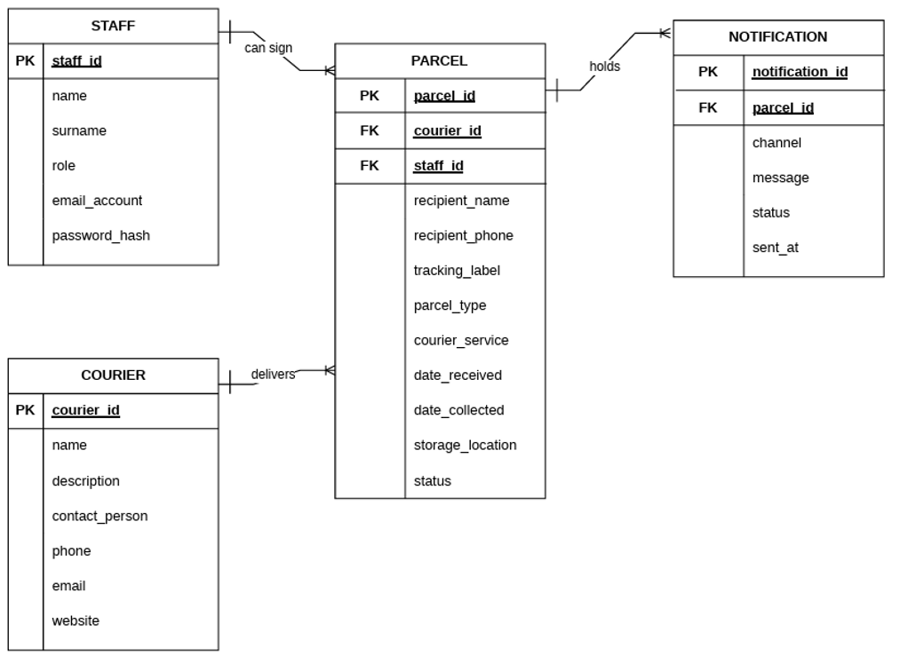

Version Control

Overview
Version control was managed using Git and GitHub, ensuring collaboration and source integrity across a team of 8 developers working virtually across three campuses. All members Work on the development branch leaving the main core branch by itself til the completion of the project
(Picture of Branches for the Hermes Transportation Platform)
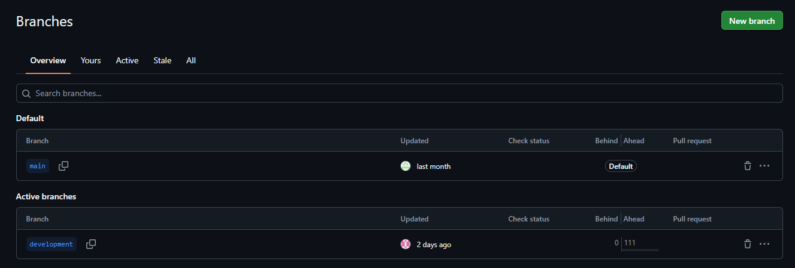

Repository Structure
The project repository, titled Hermes Transportation Platform, contains well-organized directories for the Laravel backend, React frontend, database migrations, and configuration files.
/Hermes_Platform
├── app/ # Laravel application logic
│ ├── Http/Controllers # Controllers for system features
│ ├── Mails/ # Creation of automated mail
├── bootstrap/ # Startup configuration
├── config/ # Environment and app settings
├── database/ # Migrations and seeders
├── docs/ # documentation for the repository
├── public/ # Static assets and entry point
├── resources/ # React + Inertia frontend
├── routes/ # Web and API routes
└── ...

Commit Guidelines + Collaboration Practices

The commit guidelines were as follows:

1. Run git pull origin development before you start work and before you push.
2. Never use git push --force on development.
3. Run git status before committing so you only commit what you meant to.
4. If a pull produces conflicts, stop and ask before resolving.

Collaboration Practices were as follows:

• Code development was separated between the front end and backend with the frontend developing the GUI and the backend integrating the database with the GUI as well as the processes of the system
• Pull Requests and peer reviews were used to maintain code quality.
• Discord and WhatsApp facilitated real-time coordination.
• GitHub Issues and milestones were used for progress tracking.
This version control approach fostered discipline, transparency, and alignment across all contributors, closely mirroring real-world software engineering practices.

Frontend Structures

Frontend Directory Structure
The Hermes Platform frontend code is organized within the resources/ directory. This structure follows modern React and Inertia.js best practices, ensuring a clear separation of concerns between page layouts, reusable components, business logic, and type definitions.
Below is the directory structure of the frontend:
resources/
├── css/
│ └── app.css # Global Tailwind CSS imports and custom styles
└── js/
├── app.tsx # Main frontend entry point (connects Laravel to React)
├── ssr.tsx # Server-side rendering entry point (for performance)
├── components/ # Reusable UI building blocks
│ ├── ui/ # Base accessible components (Radix UI / Headless UI wrappers)
│ ├── app-shell.tsx # Main layout wrapper (header, sidebar, content area)
│ ├── app-sidebar.tsx # Sidebar navigation container
│ ├── nav-main.tsx # Primary navigation menu items
│ └── nav-user.tsx # User profile, settings, and logout dropdown
├── hooks/ # Custom React functions (e.g., theme/appearance management)
├── layouts/ # Shared page layouts
├── lib/ # Utility functions and helper methods
├── pages/ # Screen components mapped directly to Laravel routes
│ ├── auth/ # Login and authentication screens
│ ├── Couriers/ # Courier management views
│ ├── FinancialReports/ # Admin financial reporting views
│ ├── Notifications/ # System notices and update history
│ ├── Parcels/ # Parcel tracking and management
│ ├── settings/ # User profile and application settings
│ ├── Staff/ # Staff account management (Admin only)
│ ├── Dashboard.tsx # Main operational overview screen
│ └── welcome.tsx # Landing/welcome page
└── types/ # TypeScript definitions (e.g., User, NavItem shapes)
Directory Purpose Breakdown:
Folder / File | Purpose
app.tsx | The starting point of the frontend. It initializes the Inertia.js app and tells React how to load pages sent by Laravel.
components/ | Contains reusable building blocks for the user interface. The ui/ subfolder holds standardized, accessible components (like buttons, inputs, and dialogs) to ensure the whole app looks and behaves consistently.
hooks/ | Stores custom React functions that manage specific behaviors, such as checking or setting the user's light/dark mode preference.
lib/ | Holds helper functions and utility code that can be used across different parts of the application (e.g., formatting dates, numbers, or handling API responses).
pages/ | The core of the Inertia.js routing system. Each file or folder here represents a screen the user can see. Laravel routes directly to these files (e.g., the /dashboard route loads Dashboard.tsx).
types/ | Defines the shape of our data (like what a "User" or "NavItem" looks like). This helps TypeScript catch errors early and makes the code easier for developers to read and maintain.

Why This Structure Works for Hermes: By separating reusable components (components/) from actual screens (pages/), the development team can update a single UI element (like the sidebar or a data table) and have it instantly reflect across all Admin and Staff dashboards. This keeps the codebase clean, scalable, and easy to maintain as new operational features are added.

Routing (Inertia.js)
In a traditional web application, clicking a link forces the browser to reload the entire page. The Hermes Platform avoids this by using Inertia.js, which allows the Laravel backend and the React frontend to communicate seamlessly. This creates a smooth, desktop-app-like experience where screens update instantly without full page reloads.
Here is the step-by-step journey of how a URL connects to a React screen:
Step 1: The Backend Route (routes/web.php) When a user clicks a link (for example, going to the Dashboard), the browser sends a request to the Laravel backend. The web.php file catches this URL and directs it to the correct backend controller.
// From routes/web.php
Route::middleware(['auth', 'verified'])->group(function () {
Route::get('dashboard', [DashboardController::class, 'index'])
->name('dashboard');

// ... other routes like parcels, couriers, etc.
});
Plain-English Explanation:
● Line 1: This wraps the routes in a security check. It ensures the user is logged in (auth) and has verified their account (verified) before they can see any of these screens.
● Line 2: This tells Laravel: "When someone visits the /dashboard URL, run the index function inside the DashboardController."
Step 2: The Inertia Bridge (The Controller) Instead of returning standard HTML or a separate JSON API response, the Laravel controller uses Inertia to return the name of the React screen we want to load, along with any data that screen needs.
(Conceptual example of what the controller does behind the scenes):
// Inside DashboardController.php
public function index()
{
// Fetch data from the database...
$parcels = Parcel::count();

// Tell Inertia to load the 'Dashboard' React page and pass the data to it
return Inertia::render('Dashboard', [
'parcelCount' => $parcels,
]);
}
Plain-English Explanation:
● The controller grabs the necessary data (like the number of parcels).
● Inertia::render('Dashboard', ...) acts as a bridge. It tells the frontend: "Load the React component named Dashboard and give it this data."
Step 3: The Frontend Resolver (resources/js/app.tsx) When the frontend receives the instruction to load the "Dashboard" component, it needs to find the actual React file. This is handled by the resolve function in our main app.tsx file.
// From resources/js/app.tsx
createInertiaApp({
title: (title) => title ? `${title} - ${appName}` : appName,
resolve: (name) => resolvePageComponent(`./pages/${name}.tsx`, import.meta.glob('./pages/**/*.tsx')),
setup({ el, App, props }) {
const root = createRoot(el);
root.render(<App {...props} />);
},
// ...
});
Plain-English Explanation:
● Line 3 (resolve): This is the magic link between the backend and the frontend files. When the backend asks for the "Dashboard" component, this line automatically looks inside the resources/js/pages/ folder for a file named Dashboard.tsx.
● Line 4 (setup): Once it finds the correct React file, it renders it on the screen and passes the data (props) sent from the Laravel controller directly into the React component.
Why This Matters for Hermes: Because of this routing setup, the development team doesn't need to build and maintain a separate API just to load pages. The backend and frontend stay perfectly in sync, making the desktop dashboard faster and much easier to maintain.

Data Flow & Communication
In the Hermes Platform, data flows smoothly between the Laravel backend and the React frontend without the need for complex, separate API endpoints for every page. This is handled by Inertia.js, which passes data as "props" directly into React components. When a user needs to send data back to the server (like submitting a form), Inertia handles that request seamlessly.
Step 1: Receiving Data from the Backend When a user visits a page, the Laravel controller fetches the necessary data from the database and sends it to the React component. The React component receives this data through its Props.
Here is an example from the Dashboard.tsx file, which receives statistics and recent parcel data from the backend:
type Props = {
title: string;
stats?: {
total_parcels: number;
pending_parcels: number;
ready_for_collection: number;
collected_parcels: number;
};
recent_parcels?: Parcel[];
};

export default function Dashboard({ title, stats, recent_parcels }: Props) {
// We can also access global shared data (like the logged-in user)
// using Inertia's usePage() hook.
const props = usePage().props as { auth?: { user?: { email?: string } } };
const isAdmin = props?.auth?.user?.email === 'admin@gmail.com';

// Use the data sent from Laravel, or fall back to defaults if empty
const displayStats = stats || { total_parcels: 0, pending_parcels: 0, ready_for_collection: 0, collected_parcels: 0 };
const parcels = recent_parcels || [];

return (
<DashboardLayout title={title}>
{/* Render the stats and parcels using the data passed as props */}
<p className="text-3xl font-bold">{displayStats.total_parcels}</p>
{/* ... rest of the UI */}
</DashboardLayout>
);
}

Plain-English Explanation:
● Lines 1-10: We define the exact shape of the data (Props) we expect to receive from Laravel. This ensures TypeScript catches any mismatches early.
● Line 14: We use Inertia's usePage().props to access global data that Laravel shares on every page load, such as the currently logged-in user's email. This is how we determine if the user is an Admin.
● Lines 18-19: We safely assign the data received from Laravel to local variables, providing empty defaults just in case the database returns nothing.
● Line 22: We wrap the page in DashboardLayout, which provides the consistent sidebar and header, and pass the title down to it.
Step 2: Sending Data Back to the Backend When a user interacts with the page (e.g., clicking a "Log Out" button or submitting a form), we don't need to write manual fetch or axios calls. Instead, we use Inertia's <Link> component or the router.post/router.put methods to send the data back to Laravel, just like a traditional HTML form, but without the page reload.
Here is an example of the Log Out button from the dashboard-layout.tsx file:
<Link
href="/logout"
method="post"
as="button"
className="flex w-full items-center gap-3 px-4 py-2.5 rounded-xl text-white/70 hover:text-red-400 hover:bg-red-500/10 transition-all text-sm"
>
<LogOut className="h-4 w-4" />
<span className="font-medium">Log out</span>
</Link>
Plain-English Explanation:
● href="/logout": This tells Inertia which Laravel route to target.
● method="post": This ensures the request is sent as a POST request (which is required for security reasons when destroying a session), even though it looks like a standard link.
● as="button": This renders the link as a <button> element in the final HTML, which is better for accessibility and screen readers.
● When clicked, Inertia intercepts this, sends the POST request to Laravel in the background, Laravel destroys the session, and then redirects the user to the login page, all without a full browser refresh.

Key UI Components & Layouts
To ensure the Hermes Platform looks consistent and behaves predictably across all Admin and Staff screens, the frontend relies on a strict layout system and a library of reusable UI components. This prevents code duplication and makes it easy to update the design in one place and have it apply everywhere.
The Layout System Every main screen in the application is wrapped in a shared layout component called DashboardLayout. This component is responsible for drawing the persistent sidebar, the top header, and the main content area where the specific page data is displayed.
Here is a simplified view of how dashboard-layout.tsx structures the screen:
export default function DashboardLayout({ children, title }) {
const page = usePage();
const { auth } = page.props;
const user = auth?.user;

// Navigation items, some marked as adminOnly
const navItems = [
{ name: 'Dashboard', href: '/dashboard', icon: LayoutDashboard },
{ name: 'Parcels', href: '/parcels', icon: Package },
{ name: 'Financial Reports', href: '/financial-reports', icon: LayoutDashboard, adminOnly: true },
{ name: 'Staff', href: '/staff', icon: Users, adminOnly: true },
];

return (
<div className="flex min-h-screen bg-[#f8f6fb] dark:bg-[#120b1c]">
{/* Sidebar Navigation */}
<aside className="fixed inset-y-0 left-0 w-64 bg-gradient-to-b from-[#2d1b4e] to-[#4a1a6b]">
{/* Logo and Navigation Links */}
<nav className="px-4 py-6 space-y-1 flex-1 overflow-y-auto">
{navItems
.filter((item) => !item.adminOnly || user?.email === 'admin@gmail.com')
.map((item) => (
<Link key={item.name} href={item.href} className="flex items-center gap-3 px-4 py-3 rounded-xl">
<item.icon className="h-5 w-5" />
<span>{item.name}</span>
</Link>
))}
</nav>
</aside>

{/* Main Content Area */}
<div className="flex-1 flex flex-col min-w-0">
<header className="sticky top-0 z-30 bg-white/90 backdrop-blur-md border-b border-gray-200 px-6 py-4">
<h1 className="text-xl font-bold text-[#2d1b4e]">{title}</h1>
</header>
<main className="flex-1 p-6 overflow-auto">
{children} {/* The specific page content is injected here */}
</main>
</div>
</div>
);
}
Plain-English Explanation:
● Lines 5-10: Defines the main navigation links. Notice the adminOnly: true flag on "Financial Reports" and "Staff".
● Lines 18-19: This is where role-based UI happens. The .filter() method checks if a link is adminOnly. If it is, it only shows the link if the user's email matches the admin email. Staff members never even see these links in their sidebar.
● Lines 21-25: Draws the actual sidebar link with an icon and text.
● Lines 30-36: Creates the main content area. The <header> stays sticky at the top of the screen (ideal for desktop dashboards), and the {children} prop is where the actual page (like Dashboard.tsx or Parcels/Index.tsx) is rendered.
Reusable UI Components Instead of writing custom HTML and CSS for every button, input, or dialog box, the platform uses a components/ui/ folder. This folder contains pre-styled, accessible components built on top of Radix UI and Headless UI, styled with Tailwind CSS.
For example, in Dashboard.tsx, a dialog box is created like this:
import { Button } from '@/components/ui/button';
import { Dialog, DialogContent, DialogHeader, DialogTitle, DialogTrigger } from '@/components/ui/dialog';

// ... inside the component return statement:
<Dialog>
<DialogTrigger asChild>
<Button className="bg-gradient-to-r from-[#f5a623] to-[#e85d04] text-white">
Open Dialog
</Button>
</DialogTrigger>
<DialogContent className="bg-white rounded-2xl shadow-xl">
<DialogHeader>
<DialogTitle>Hermes Dashboard</DialogTitle>
</DialogHeader>
<p>Dialog content goes here.</p>
</DialogContent>
</Dialog>
Plain-English Explanation:
● Dialog & DialogTrigger: These components handle the complex logic of opening and closing a pop-up window, including keyboard accessibility (like pressing 'Escape' to close).
● asChild: This tells the trigger to apply the dialog's behavior directly to our custom styled Button, rather than wrapping it in an extra, unnecessary HTML element.
● DialogContent: This is the actual pop-up box. We apply our own Tailwind CSS classes (like bg-white rounded-2xl shadow-xl) to make it match the Hermes Platform design, while Radix UI handles the underlying accessibility and focus management.
Why This Matters for Hermes: By separating the layout (DashboardLayout) and the base UI pieces (components/ui/) from the actual page logic, developers can focus on building features (like parcel tracking or financial reports) without worrying about making the sidebar look right or ensuring buttons are accessible. It keeps the codebase clean, professional, and easy to scale.

State Management & Custom Hooks
In modern web applications, managing state (data that changes over time) can become complex. The Hermes Platform avoids heavy, complicated state management libraries (like Redux) by leveraging Inertia.js for global data and custom React hooks for localized, reusable logic.
Global State via Inertia.js, For data that needs to be available across the entire application (like the currently logged-in user or UI preferences), Hermes relies on Inertia's shared props. Instead of making separate API calls to fetch user data on every page, Laravel injects this data directly into the frontend on every request.
We define the exact shape of this shared data in our TypeScript types (resources/js/types/index.d.ts):
export interface SharedData {
name: string;
quote: { message: string; author: string };
auth: {
user: {
id: number;
name: string;
email: string;
role: string;
// ... other user properties
} | null;
};
sidebarOpen: boolean;
[key: string]: unknown;
}
Plain-English Explanation:
● This SharedData interface acts as a central blueprint. It tells TypeScript exactly what data to expect from the backend on every page load.
● Because the auth.user object is always available, any component can instantly check who is logged in and what their role is, without needing a separate global state manager.
Custom Hooks for Reusable Logic For UI-specific state (like toggling dark mode or handling mobile menus), we use custom React hooks. Hooks allow us to extract state logic out of components so it can be reused cleanly.
A perfect example is the use-appearance.tsx hook, which manages the platform's light/dark mode:
import { useCallback, useEffect, useState } from 'react';

export type Appearance = 'light' | 'dark' | 'system';

export function useAppearance() {
const [appearance, setAppearance] = useState<Appearance>('system');

const updateAppearance = useCallback((mode: Appearance) => {
setAppearance(mode);
localStorage.setItem('appearance', mode); // Save for next visit
applyTheme(mode); // Update the screen immediately
}, []);

useEffect(() => {
// Load the saved preference when the app starts
const savedAppearance = localStorage.getItem('appearance') as Appearance | null;
updateAppearance(savedAppearance || 'system');
}, [updateAppearance]);

return { appearance, updateAppearance } as const;
}
Plain-English Explanation:
● Line 6: We create a piece of state called appearance that defaults to 'system' (meaning it matches the user's computer settings).
● Lines 8-13: The updateAppearance function does three things: it updates the React state, saves the user's choice to the browser's localStorage (so it remembers their choice next time they visit), and instantly applies the visual theme to the screen.
● Lines 15-20: When the component loads, the useEffect hook checks localStorage for a saved preference and applies it.
● Line 22: We return the state and the update function as a constant (as const), which helps TypeScript understand exactly what this hook provides.
Why This Approach Works for Hermes By combining Inertia's shared props for global data and custom hooks for UI behavior, the Hermes Platform keeps its codebase lightweight and easy to maintain. Developers don't have to trace data through complex state trees; they simply read the props provided by Laravel or call a dedicated hook.

UI/UX Design
The Hermes Platform is explicitly designed for desktop and laptop environments, providing a high-density, data-rich interface that allows Administrators and Staff to manage complex operations efficiently. The design prioritizes clarity, consistency, and quick access to critical information.
Desktop-Optimized Dashboard Layout The main dashboard uses a two-column layout with a persistent sidebar on the left and the main content area on the right. This layout is ideal for desktop screens, allowing users to navigate between different sections (Parcels, Couriers, Notifications, etc.) without losing context.
Here is a simplified view of the dashboard structure from Dashboard.tsx:
export default function Dashboard({ title, stats, recent_parcels }: Props) {
return (
<DashboardLayout title={title}>
<div className="max-w-7xl mx-auto space-y-6">
{/* Header Section */}
<div className="flex items-center justify-between">
<div>
<h2 className="text-2xl font-bold text-[#2d1b4e]">Dashboard Overview</h2>
<p className="text-gray-500 mt-1">Welcome back! Here's what's happening today.</p>
</div>
</div>

{/* Stats Grid - 4 columns on large screens */}
<div className="grid grid-cols-1 sm:grid-cols-2 lg:grid-cols-4 gap-4">
{/* Total Parcels Card */}
<div className="bg-white rounded-2xl p-6 shadow-sm border border-gray-100">
<p className="text-3xl font-bold text-[#2d1b4e]">{displayStats.total_parcels.toLocaleString()}</p>
<p className="text-sm text-gray-500 mt-1">Total Parcels</p>
</div>
{/* ... other stat cards */}
</div>

{/* Recent Activity and Quick Actions */}
<div className="grid grid-cols-1 lg:grid-cols-3 gap-6">
{/* Recent Parcels List - Takes 2/3 of the width */}
<div className="lg:col-span-2 bg-white rounded-2xl shadow-sm border border-gray-100">
{/* Parcel list content */}
</div>

{/* Quick Actions Panel - Takes 1/3 of the width */}
<div className="bg-white rounded-2xl shadow-sm border border-gray-100 p-6 space-y-3">
{/* Action buttons */}
</div>
</div>
</div>
</DashboardLayout>
);
}
Plain-English Explanation:
● Line 5: max-w-7xl mx-auto centers the content and limits its maximum width, ensuring the dashboard doesn't stretch too wide on large monitors.
● Line 13: grid grid-cols-1 sm:grid-cols-2 lg:grid-cols-4 creates a responsive grid. On desktop screens (lg:), it shows 4 stat cards in a row. On smaller screens, it adjusts to 2 or 1 column.
● Line 23: lg:col-span-2 makes the "Recent Parcels" section take up 2/3 of the available width, while the "Quick Actions" panel takes the remaining 1/3. This layout prioritizes the most important information (parcel activity) while keeping quick actions accessible.
Data Visualization and Stats Cards The dashboard uses clean, card-based design to display key metrics. Each stat card includes an icon, a large number, and a descriptive label, making it easy for users to quickly assess the platform's status.
{/* Total Parcels Card */}
<div className="bg-white rounded-2xl p-6 shadow-sm border border-gray-100 hover:shadow-md transition-shadow">
<div className="flex items-center justify-between mb-4">
<div className="h-12 w-12 rounded-xl bg-[#2d1b4e]/10 flex items-center justify-center">
<Package className="h-6 w-6 text-[#2d1b4e]" />
</div>
</div>
<p className="text-3xl font-bold text-[#2d1b4e]">{displayStats.total_parcels.toLocaleString()}</p>
<p className="text-sm text-gray-500 mt-1">Total Parcels</p>
</div>
Plain-English Explanation:
● Line 1: The card uses bg-white rounded-2xl shadow-sm to create a clean, elevated appearance. The hover:shadow-md adds a subtle shadow when the user hovers over it, providing visual feedback.
● Lines 3-6: The icon is placed in a colored circle (h-12 w-12 rounded-xl) to make it visually distinct. The color (bg-[#2d1b4e]/10) matches the platform's brand color.
● Line 8: text-3xl font-bold makes the number large and prominent, allowing users to see the metric at a glance.
● Line 9: toLocaleString() formats the number with commas (e.g., "1,234" instead of "1234"), making large numbers easier to read.
Navigation and Information Architecture The sidebar navigation is organized into logical sections, with clear visual hierarchy. Active links are highlighted with a colored background and an accent bar on the left, making it obvious which section the user is currently viewing.
From dashboard-layout.tsx:
<nav className="px-4 py-6 space-y-1 flex-1 overflow-y-auto">
{navItems
.filter((item) => !item.adminOnly || user?.email === 'admin@gmail.com')
.map((item) => {
const active = isNavItemActive(item.href);
return (
<Link
key={item.name}
href={item.href}
className={`flex items-center gap-3 px-4 py-3 rounded-xl transition-all group ${
active
? 'bg-white/10 text-white before:absolute before:left-0 before:top-1/2 before:-translate-y-1/2 before:h-6 before:w-1 before:rounded-r-full before:bg-[#f5a623] relative'
: 'text-white/70 hover:text-white hover:bg-white/10'
}`}
>
<item.icon className={`h-5 w-5 transition-colors ${active ? 'text-[#f5a623]' : 'group-hover:text-[#f5a623]'}`} />
<span className="font-medium text-sm">{item.name}</span>
</Link>
);
})}
</nav>
Plain-English Explanation:
● Line 3: The .filter() method hides admin-only links (like "Financial Reports" and "Staff") from regular Staff users, keeping the navigation clean and relevant.
● Line 10: The active variable checks if the current URL matches the link's destination.
● Lines 13-16: If the link is active, it gets a white background (bg-white/10), white text, and a colored accent bar on the left (before:bg-[#f5a623]). If it's not active, it's semi-transparent (text-white/70) and becomes fully white on hover.
● Line 19: The icon color also changes based on the active state, providing consistent visual feedback.
Design Principles The Hermes Platform follows these key design principles:
- Consistency: All buttons, cards, and form inputs use the same styling and spacing, creating a predictable user experience.
- Clarity: Important information (like parcel counts and status) is displayed prominently using large text and clear labels.
- Accessibility: The platform uses semantic HTML, proper color contrast, and keyboard navigation support to ensure it's usable by everyone.
- Role-Based Views: The interface automatically adapts to show only the tools and data relevant to each user's role, reducing clutter and confusion.
- Performance: The desktop-optimized layout loads quickly and responds instantly to user actions, thanks to Inertia.js and Vite.

Backend Structure
Backend Structure describes how the application represents and stores data. It includes Eloquent models, model relationships, database migrations, factories for generating records, and seeders for initializing sample/default data.

Models and relationships
Models represent database records and define their properties/relationships. From the supplied code, Courier has many parcels; Staff has many parcels; Parcel belongs to a courier and staff member and has many notifications; Notification belongs to a parcel. Setting is a key-value model without an explicit relationship shown.

Courier
app/Models/Courier.php
Represents couriers and defines the relationship to their parcels.
<?php

namespace App\Models;

use Illuminate\Database\Eloquent\Factories\HasFactory;
use Illuminate\Database\Eloquent\Model;
use Illuminate\Database\Eloquent\Relations\HasMany;

class Courier extends Model
{
use HasFactory;

protected $primaryKey = 'courier_id';

protected $fillable = [
'name',
'description',
'contact_person',
'contact_number',
'email',
'website',
];

public function parcels(): HasMany
{
return $this->hasMany(Parcel::class, 'courier_id', 'courier_id');
}
} //They asked me how well I understood theoretical physics. I said I had a theoretical degree in physics. They said welcome aboard.

Staff
app/Models/Staff.php
Represents staff accounts and supports authentication, notifications, Sanctum API tokens, and parcel relationships.
<?php

namespace App\Models;

use Illuminate\Database\Eloquent\Factories\HasFactory;
use Illuminate\Database\Eloquent\Relations\HasMany;
use Illuminate\Foundation\Auth\User as Authenticatable;
use Illuminate\Notifications\Notifiable;
use Laravel\Sanctum\HasApiTokens;

class Staff extends Authenticatable
{
use HasApiTokens, HasFactory, Notifiable;

protected $primaryKey = 'staff_id';

protected $fillable = [
'name',
'surname',
'role',
'email_account',
'password_hash',
];

protected $hidden = [
'password_hash',
'remember_token',
];

protected $casts = [
'email_verified_at' => 'datetime',
'password_hash' => 'hashed',
];

public function getAuthPassword(): string
{
return $this->password_hash;
}

public function username(): string
{
return 'email_account';
}

public function parcels(): HasMany
{
return $this->hasMany(Parcel::class, 'staff_id', 'staff_id');
}
}

Parcel
app/Models/Parcel.php
Represents parcels and their relationships to courier, staff, and notification records.
<?php

namespace App\Models;

use Illuminate\Database\Eloquent\Model;
use Illuminate\Database\Eloquent\Factories\HasFactory;
use Illuminate\Database\Eloquent\Relations\BelongsTo;
use Illuminate\Database\Eloquent\Relations\HasMany;

class Parcel extends Model
{
use HasFactory;

protected $primaryKey = 'parcel_id';

protected $fillable = [
'courier_id',
'staff_id',
'recipient_name',
'recipient_phone',
'recipient_email',
'tracking_number',
'parcel_type',
'courier_service',
'date_received',
'date_collected',
'storage_location',
'status',
'collection_fee',
];

// FIX: Added date casts to ensure proper comparisons in controllers
protected $casts = [
'date_received' => 'date',
'date_collected' => 'date',
'collection_fee' => 'decimal:2',
];

public function courier(): BelongsTo
{
return $this->belongsTo(Courier::class, 'courier_id', 'courier_id');
}

public function staff(): BelongsTo
{
return $this->belongsTo(Staff::class, 'staff_id', 'staff_id');
}

public function notifications(): HasMany
{
return $this->hasMany(Notification::class, 'parcel_id', 'parcel_id');
}
}

Notification
app/Models/Notification.php
Represents notification records, including channel/message/status/timestamp, linked to a parcel.
<?php

namespace App\Models;

use Illuminate\Database\Eloquent\Factories\HasFactory;
use Illuminate\Database\Eloquent\Model;
use Illuminate\Database\Eloquent\Relations\BelongsTo;

class Notification extends Model
{
use HasFactory;

protected $primaryKey = 'notification_id';

protected $fillable = [
'parcel_id',
'channel',
'message',
'status',
'sent_at',
];

protected $casts = [
'sent_at' => 'datetime',
];

// You're a courier. You bring the message, even if you don't like what it says.

public function parcel(): BelongsTo
{
return $this->belongsTo(Parcel::class, 'parcel_id', 'parcel_id');
}
}

Setting
app/Models/Setting.php
Represents the key-value settings records stored in the settings table.
<?php
// "We can't expect God to do all the work." — Joshua Graham
namespace App\Models;

use Illuminate\Database\Eloquent\Factories\HasFactory;
use Illuminate\Database\Eloquent\Model;

class Setting extends Model
{
use HasFactory;

protected $fillable = [
'key',
'value',
];
}

Database migrations
Migrations define the database schema. Migration filenames/timestamps were not present in the source document, so entries are labeled by the table or change they implement.

Staff table
database/migrations/[migration filename not provided]
Creates the staff table, including identity, role, email, password hash, remember token, and timestamps.
<?php

use Illuminate\Database\Migrations\Migration;
use Illuminate\Database\Schema\Blueprint;
use Illuminate\Support\Facades\Schema;

return new class extends Migration
{
public function up(): void
{
Schema::create('staff', function (Blueprint $table) {
$table->id('staff_id');
$table->string('name');
$table->string('surname');
$table->string('role');
$table->string('email_account')->unique();
$table->timestamp('email_verified_at')->nullable();
$table->string('password_hash'); // No one survives the Mojave without a bit of luck, but luck runs out.
$table->rememberToken();
$table->timestamps();
});
}

public function down(): void
{
Schema::dropIfExists('staff');
}
};

Couriers table
database/migrations/[migration filename not provided]
Creates the couriers table and its contact/description fields.
<?php

use Illuminate\Database\Migrations\Migration;
use Illuminate\Database\Schema\Blueprint;
use Illuminate\Support\Facades\Schema;

return new class extends Migration
{
public function up(): void
{
Schema::create('couriers', function (Blueprint $table) {
$table->id('courier_id');
$table->string('name');
$table->text('description')->nullable();
$table->string('contact_person')->nullable();
$table->string('contact_number')->nullable();
$table->string('email')->nullable();
$table->string('website')->nullable();
$table->timestamps();
});
}

public function down(): void
{
Schema::dropIfExists('couriers');
}
};

Parcels table
database/migrations/[migration filename not provided]
Creates the parcels table and foreign keys to couriers and staff, plus recipient, tracking, parcel, date, status, storage, and fee fields.
<?php

use Illuminate\Database\Migrations\Migration;
use Illuminate\Database\Schema\Blueprint;
use Illuminate\Support\Facades\Schema;

return new class extends Migration
{
public function up(): void
{
Schema::create('parcels', function (Blueprint $table) {
$table->id('parcel_id');

$table->foreignId('courier_id')
->constrained('couriers', 'courier_id')
->cascadeOnDelete();

$table->foreignId('staff_id')
->constrained('staff', 'staff_id')
->cascadeOnDelete();

$table->string('recipient_name');
$table->string('recipient_phone');

$table->string('tracking_number')->unique();
$table->string('parcel_type');
$table->string('courier_service')->nullable();
$table->date('date_received')->nullable();
$table->date('date_collected')->nullable();
$table->string('storage_location');
$table->string('status');
$table->decimal('collection_fee', 8, 2);

$table->timestamps();
});
}

public function down(): void
{
Schema::dropIfExists('parcels');
}
};

Recipient email column
database/migrations/[migration filename not provided]
Adds a nullable recipient_email column to parcels and defines its rollback.
<?php

use Illuminate\Database\Migrations\Migration;
use Illuminate\Database\Schema\Blueprint;
use Illuminate\Support\Facades\Schema;

return new class extends Migration
{
public function up(): void
{
Schema::table('parcels', function (Blueprint $table) {
$table->string('recipient_email')->nullable()->after('recipient_phone');
});
}

public function down(): void
{
Schema::table('parcels', function (Blueprint $table) {
$table->dropColumn('recipient_email');
});
}
};

Additional parcels migration (empty)
database/migrations/[migration filename not provided]
Contains empty Schema::table callbacks for parcels and makes no schema change in the supplied code.
<?php

use Illuminate\Database\Migrations\Migration;
use Illuminate\Database\Schema\Blueprint;
use Illuminate\Support\Facades\Schema;

return new class extends Migration
{
/**
* Run the migrations.
*/
public function up(): void
{
Schema::table('parcels', function (Blueprint $table) {
//
});
}

/**
* Reverse the migrations.
*/
public function down(): void
{
Schema::table('parcels', function (Blueprint $table) {
//
});
}
};

Notifications table
database/migrations/[migration filename not provided]
Creates notification records linked to parcels, including channel, message, status, sent time, and timestamps.
<?php

use Illuminate\Database\Migrations\Migration;
use Illuminate\Database\Schema\Blueprint;
use Illuminate\Support\Facades\Schema;

return new class extends Migration
{
public function up(): void
{
Schema::create('notifications', function (Blueprint $table) {
$table->id('notification_id');

$table->foreignId('parcel_id')
->constrained('parcels', 'parcel_id')
->cascadeOnDelete();

$table->string('channel');
$table->text('message');
$table->string('status');
$table->dateTime('sent_at')->nullable();

$table->timestamps();
});
}

public function down(): void
{
Schema::dropIfExists('notifications');
}
};

Settings table
database/migrations/[migration filename not provided]
Creates key-value settings storage with a unique key.
<?php

use Illuminate\Database\Migrations\Migration;
use Illuminate\Database\Schema\Blueprint;
use Illuminate\Support\Facades\Schema;

return new class extends Migration
{
/**
* Run the migrations.
*/
public function up(): void
{
Schema::create('settings', function (Blueprint $table) {
$table->id();
$table->string('key')->unique(); // e.g., 'companyName', 'trackingPrefix'
$table->text('value')->nullable(); // The actual value
$table->timestamps();
});
}

/**
* Reverse the migrations.
*/
public function down(): void
{
Schema::dropIfExists('settings');
}
};

Sanctum personal access tokens table
database/migrations/[migration filename not provided]
Creates the personal_access_tokens table used by Laravel Sanctum.
<?php

use Illuminate\Database\Migrations\Migration;
use Illuminate\Database\Schema\Blueprint;
use Illuminate\Support\Facades\Schema;

return new class extends Migration
{
/**
* Run the migrations.
*/
public function up(): void
{
Schema::create('personal_access_tokens', function (Blueprint $table) {
$table->id();
$table->morphs('tokenable');
$table->text('name');
$table->string('token', 64)->unique();
$table->text('abilities')->nullable();
$table->timestamp('last_used_at')->nullable();
$table->timestamp('expires_at')->nullable()->index();
$table->timestamps();
});
}

/**
* Reverse the migrations.
*/
public function down(): void
{
Schema::dropIfExists('personal_access_tokens');
}
};

Cache and cache locks tables
database/migrations/[migration filename not provided]
Creates database-backed cache and cache-lock tables.
<?php

use Illuminate\Database\Migrations\Migration;
use Illuminate\Database\Schema\Blueprint;
use Illuminate\Support\Facades\Schema;

return new class extends Migration
{
/**
* Run the migrations.
*/
public function up(): void
{
Schema::create('cache', function (Blueprint $table) {
$table->string('key')->primary();
$table->mediumText('value');
$table->integer('expiration');
});

Schema::create('cache_locks', function (Blueprint $table) {
$table->string('key')->primary();
$table->string('owner');
$table->integer('expiration');
});
}

/**
* Reverse the migrations.
*/
public function down(): void
{
Schema::dropIfExists('cache');
Schema::dropIfExists('cache_locks');
}
};

Queue/job support tables
database/migrations/[migration filename not provided]
Creates jobs, job_batches, and failed_jobs tables for queue processing and failure tracking.
<?php

use Illuminate\Database\Migrations\Migration;
use Illuminate\Database\Schema\Blueprint;
use Illuminate\Support\Facades\Schema;

return new class extends Migration
{
/**
* Run the migrations.
*/
public function up(): void
{
Schema::create('jobs', function (Blueprint $table) {
$table->id();
$table->string('queue')->index();
$table->longText('payload');
$table->unsignedTinyInteger('attempts');
$table->unsignedInteger('reserved_at')->nullable();
$table->unsignedInteger('available_at');
$table->unsignedInteger('created_at');
});

Schema::create('job_batches', function (Blueprint $table) {
$table->string('id')->primary();
$table->string('name');
$table->integer('total_jobs');
$table->integer('pending_jobs');
$table->integer('failed_jobs');
$table->longText('failed_job_ids');
$table->mediumText('options')->nullable();
$table->integer('cancelled_at')->nullable();
$table->integer('created_at');
$table->integer('finished_at')->nullable();
});

Schema::create('failed_jobs', function (Blueprint $table) {
$table->id();
$table->string('uuid')->unique();
$table->text('connection');
$table->text('queue');
$table->longText('payload');
$table->longText('exception');
$table->timestamp('failed_at')->useCurrent();
});
}

/**
* Reverse the migrations.
*/
public function down(): void
{
Schema::dropIfExists('jobs');
Schema::dropIfExists('job_batches');
Schema::dropIfExists('failed_jobs');
}
};

Factories
Factories generate plausible records for tests and development seeding.

ParcelFactory
database/factories/ParcelFactory.php
Generates sample parcel records for testing or seeding.
<?php
namespace Database\Factories;

use App\Models\Courier;
use App\Models\Staff;
use Illuminate\Database\Eloquent\Factories\Factory;

class ParcelFactory extends Factory
{
public function definition(): array
{
$received = fake()->dateTimeBetween('-2 months', 'now');
$status = fake()->randomElement(['received', 'collected']);
return [
'courier_id' => Courier::inRandomOrder()->first()?->courier_id ?? Courier::factory(),
'staff_id' => Staff::inRandomOrder()->first()?->staff_id ?? Staff::factory(),
'recipient_name' => fake()->name(),
'recipient_phone' => '+27 ' . fake()->numerify('##########'),
'recipient_email' => fake()->safeEmail(),
'tracking_number' => strtoupper(fake()->unique()->bothify('HP-########')),
'parcel_type' => fake()->randomElement(['box', 'envelope', 'bag', 'tube', 'flyer']),
'courier_service' => fake()->randomElement(['DHL', 'CourierGuy', 'Aramex', 'PostNet']),
'date_received' => $received,
'date_collected' => $status==='collected'?fake()->dateTimeBetween($received, 'now') : null,
'storage_location' => 'Shelf ' . fake()->randomLetter() . fake()->numberBetween(1, 20),
'status' => $status,
'collection_fee' => 10,
];
}
}

StaffFactory
database/factories/StaffFactory.php
Generates sample staff records, roles, and hashed passwords.
<?php

namespace Database\Factories;

use App\Models\Staff;
use Illuminate\Database\Eloquent\Factories\Factory;
use Illuminate\Support\Facades\Hash;

/**
* @extends Factory<Staff>
*/
class StaffFactory extends Factory
{
/**
* Define the model's default state.
*
* @return array<string, mixed>
*/
public function definition(): array
{
return [
'name' => fake()->firstName(),
'surname' => fake()->lastName(),
'role' => fake()->randomElement(['front_desk', 'admin']),
'email_account' => fake()->unique()->safeEmail(),
'email_verified_at' => now(),
'password_hash' => Hash::make('password'),
];
}
}

NotificationFactory
database/factories/NotificationFactory.php
Generates sample notification records.
<?php

namespace Database\Factories;

use App\Models\Parcel;
use Illuminate\Database\Eloquent\Factories\Factory;

/**
* @extends Factory<\App\Models\Notification>
*/
class NotificationFactory extends Factory
{
public function definition(): array
{
$status = fake()->randomElement(['pending', 'sent', 'failed']);
// Finding it though, that's not the hard part. It's letting go.
return [
'parcel_id' => Parcel::inRandomOrder()->first()?->parcel_id ?? Parcel::factory(),
'channel' => 'sms',
'message' => 'Your package is ready for collection.',
'status' => $status,
'sent_at' => $status === 'sent' ? fake()->dateTimeBetween('-1 month', 'now') : null,
];
}
}

CourierFactory
database/factories/CourierFactory.php
Generates sample courier records.
<?php

namespace Database\Factories;

use App\Models\Courier;
use Illuminate\Database\Eloquent\Factories\Factory;

/**
* @extends Factory<Courier>
*/
class CourierFactory extends Factory
{
public function definition(): array
{
return [
'name' => fake()->company(),
'description' => fake()->sentence(),
'contact_person' => fake()->name(),
'contact_number' => fake()->phoneNumber(),
'email' => fake()->unique()->companyEmail(),
'website' => fake()->url(),
];
}
}

Seeders
Seeders populate the database with baseline or demonstration records. The descriptions reflect the supplied code and are not modifications to it.

DatabaseSeeder
database/seeders/DatabaseSeeder.php
Entry point that calls the configured seeders.
<?php

namespace Database\Seeders;

use Illuminate\Database\Seeder;

class DatabaseSeeder extends Seeder
{
public function run(): void
{
$this->call([
StaffSeeder::class,
DefaultAccessSeeder::class,
CourierSeeder::class, // You are a courier, hired by the Mojave Express to deliver a package to the New Vegas Strip. What seemed like a simple delivery job has taken a turn... for the worse.
ParcelSeeder::class,
NotificationSeeder::class,
]);
}
}

StaffSeeder
database/seeders/StaffSeeder.php
Seeds staff records (the supplied code creates ten staff records).
<?php

namespace Database\Seeders;

use App\Models\Staff;
use Illuminate\Database\Seeder;

class StaffSeeder extends Seeder
{
public function run(): void
{
Staff::factory(10)->create();
}
}

DefaultAccessSeeder
database/seeders/DefaultAccessSeeder.php
Creates default admin and front-desk accounts if they are missing; passwords are hashed in the supplied code.
<?php

namespace Database\Seeders;

use App\Models\Staff;
use Illuminate\Database\Console\Seeds\WithoutModelEvents;
use Illuminate\Database\Seeder;
use Illuminate\Support\Facades\Hash;

class DefaultAccessSeeder extends Seeder
{
/**
* Run the database seeds.
*/
public function run(): void
{
// Create admin user (idempotent)
$adminEmail = 'admin@gmail.com';
$admin = Staff::firstOrCreate(
['email_account' => $adminEmail],
[
'name' => 'admin',
'surname' => 'admin',
'role' => 'admin',
'email_account' => 'admin@gmail.com',
'password_hash' => Hash::make('admin1234'),
]
);

$front_deskEmail = 'front_desk@gmail.com';
$front_desk = Staff::firstOrCreate(
['email_account' => $front_deskEmail],
[
'name' => 'front_desk',
'surname' => 'front_desk',
'role' => 'front_desk',
'email_account' => 'front_desk@gmail.com',
'password_hash' => Hash::make('front_desk1234'),
]
);

}
}

CourierSeeder
database/seeders/CourierSeeder.php
Seeds five courier records in the supplied code.
<?php

namespace Database\Seeders;

use App\Models\Courier;
use Illuminate\Database\Seeder;

// Welcome back to the program. This is Mr. New Vegas, and I hope I'm not comin' on too strong.

class CourierSeeder extends Seeder
{
public function run(): void
{
Courier::factory(5)->create();
}
}

ParcelSeeder
database/seeders/ParcelSeeder.php
Seeds parcel records (the supplied code creates 800 parcels).
<?php

namespace Database\Seeders;

use App\Models\Parcel;
use Illuminate\Database\Seeder;

class ParcelSeeder extends Seeder
{
public function run(): void
{
Parcel::factory(800)->create();
}
}

NotificationSeeder
database/seeders/NotificationSeeder.php
Seeds 60 notification records in the supplied code.
<?php

namespace Database\Seeders;

use App\Models\Notification;
use Illuminate\Database\Seeder;

class NotificationSeeder extends Seeder
{
// There's a difference between a road and a destination. You're looking at the dust, not where it leads.
public function run(): void
{
Notification::factory(60)->create();
}
}

Testing and Quality Assurance

Testing Overview
Testing was conducted through developer testing that looked to take advantage of the system by actively misusing the system through incorrect data entry, incomplete forms and malicious use of the system.

Developer Testing
The goal of developer testing was to confirm that each page was correct. To ensure that inputs resulted in the desired outputs, unit testing was performed on each controller and model.
Tools and methods included:
• Postman for endpoint verification.
• Mock data generation for testing database interactions without production data risks.

Quality Assurance Process
After each testing phase, a structured Quality Assurance (QA) review ensured compliance with functional and non-functional requirements. QA focused on four core dimensions:
1. Functional Accuracy: Verification of expected system behaviour across all endpoints. The requests of the project were regularly pooled and informed of updates and their feedback was acquired to help targeting of specific feature
2. Performance Testing: Testing how long the system takes to respond to requests and confirming they are within respectable times
3. Security Auditing: Confirming access to the system is only available to authenticated users.
4. Regression Testing: Re-tested existing features after bug fixes to ensure stability and backward compatibility.

Security Measures
The system uses several methods and practices to ensure that those who need access to the system, do in fact have access to it as well as the information that they are to be privy to. The System implements strict Role-Based Access Control (RBAC) and uses Laravel Sanctum for authentication.
In terms of the users themselves, they are tasked with creating a username and password that the system will use to authenticate their ability to access the system and determine their role.
These methods include :
• Sensitive operations (Parcel creation and status changing, etc) are protected by middleware that verifies user roles before access is granted.
• All data transmitted between frontend and backend is encrypted using HTTPS.
• The system complies with POPIA (Protection of Personal Information Act) standards to ensure privacy of student and staff data.

Installation Guide

Intro
This section of the document will guide you through the steps needed to install all the prerequisite programs and software needed for the Hermes Platform System as well as how to configure them for the initial setup and how to access the system. This document is to be used in tandem with the Herms Platform User Guide which shows you how to navigate through the system once it has been installed. This guide makes the assumption you are going to install and run this system on a Windows 11 machine.

Prerequisite Programs and Software
In the table below you will find a list of all software and programs needed to install the Hermes Platform system

Tool | Version | Notes
PHP | 8.2 recommended | The project was built and tested on 8.2.
Composer | Latest | Windows: use the Composer-Setup.exe installer from getcomposer.org.
Node.js + npm | 18 or higher | npm installs with Node.js program
Git | Latest | Used to run commands for the system
Xxamp | Latest
Visual Code | Latest | Used to view and edit other software

Links to software
For all programs the default options for all the installers will be correct, this next sections provides links to all the software so you my download them and has a visual guide for each of the installers

Xxamp: Xxamp Download

When clicking on the link you will be taken to Xxamp’s webpage where you will be able to download and install Xxamp. Find the table with your operating system. Once found, look for the latest version and click the download button in its row.
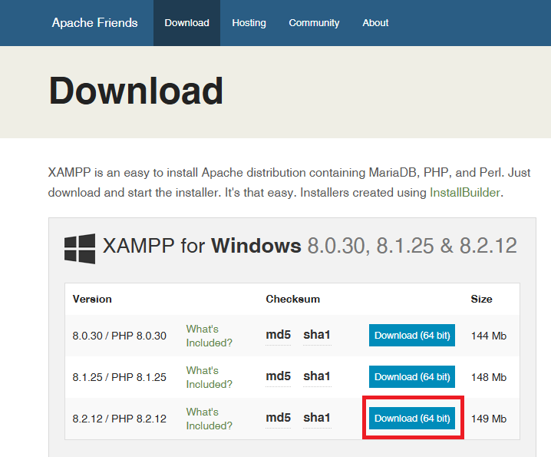
Once downloaded execute the installer and follow the pictures below, click on next in the bottom right
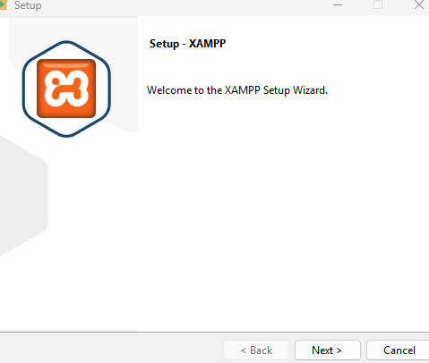
Next leave everything on the right side as the default with everything selected and then click next at the bottom right
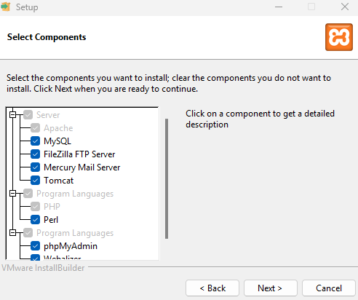
On the next page you will select a folder for where Xxamp will be installed, click next after you have selected the chosen folder
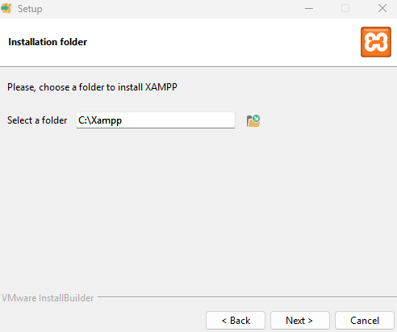
The program will now install, Once it has completed, click on the finish button

PHP: PHP Download

When clicking on the link you will be taken to the PHP download page, please configure at the top of the page what operating system you are using, please select ZIP downloads and Default PHP. These should be the default options but verify that the choices are correct, (refer to the picture below for guidance)
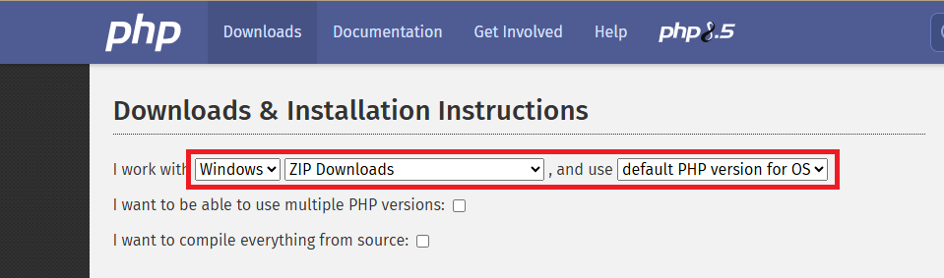
Once configured scroll down the webpage until you reach the PHP version number and then click on the source code link only
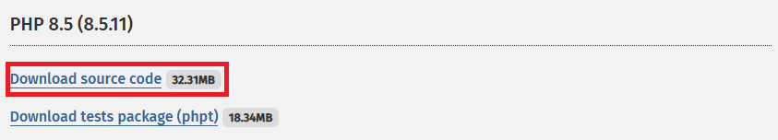

Once downloaded, extract the files to anywhere on your computer, You have finished installing PHP

Composer: Composer download

This link will drop on composer’s webpage, please click on the Composer-setup.exe to download it and then execute it once you have downloaded it.
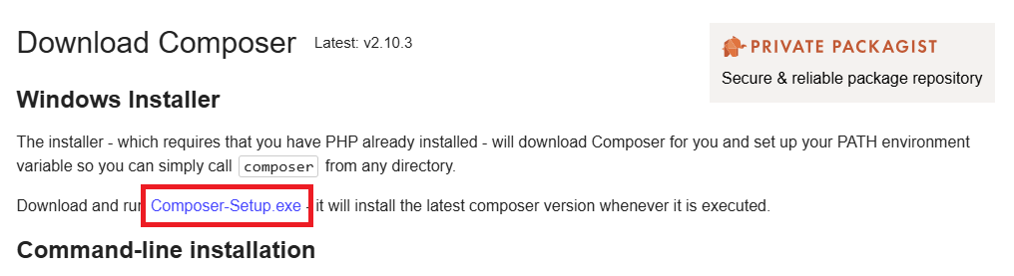
After you have downloaded the file, execute it and select either install for all or install for me only, this guide picked install for me only
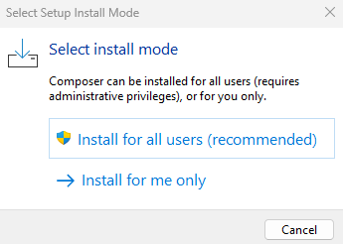
On the next page, click next. Do not tick the check box for developer mode
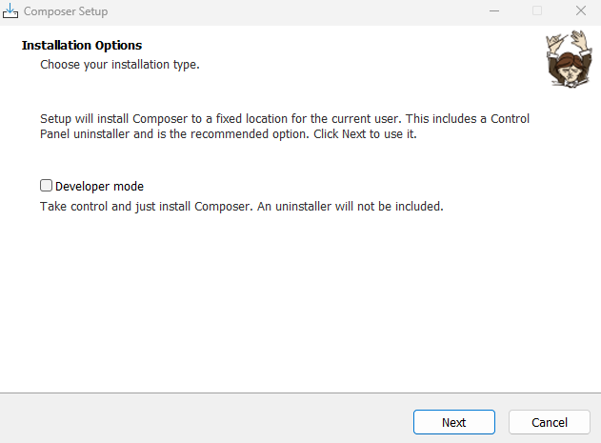
On the next page the default folder selected should be your Xxamp PHP file. Make sure that it is and then click next at the bottom right of the page
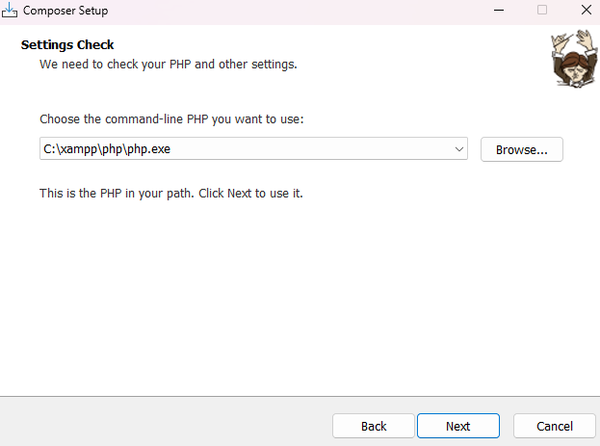
Composer is now being installed, Once completed, click on the finish button

Node.js : Node js Download

Once you click on the link above you will be taken to Node.js webpage, scroll down to the section where you can get a prebuilt installer, select your operating system and architecture
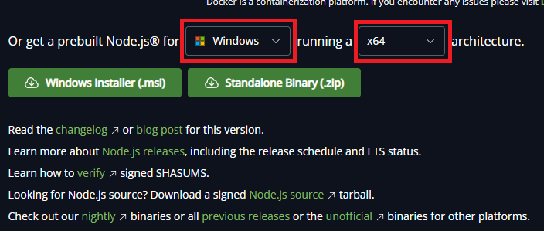
Afterwards click on the installer button for your OS and not the standalone Binary
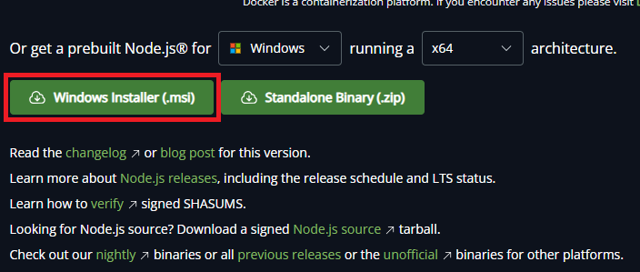

Once you have downloaded the installer, execute it and then click next
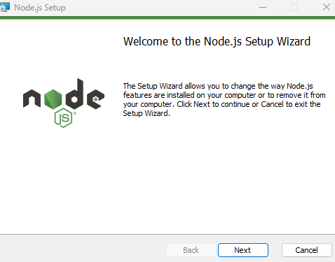

Click on the check box to accept the license Agreement and then click on the next button
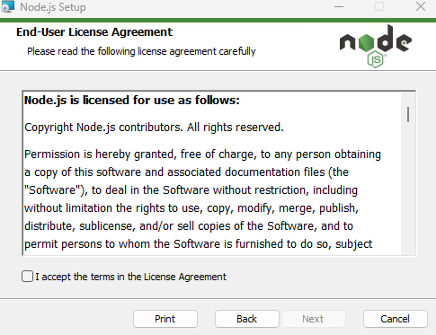
Next you must choose which folder node must be installed into. Click on next once you have selected
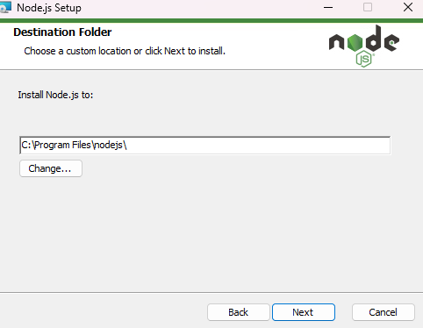

Next leave all the default options and click on next
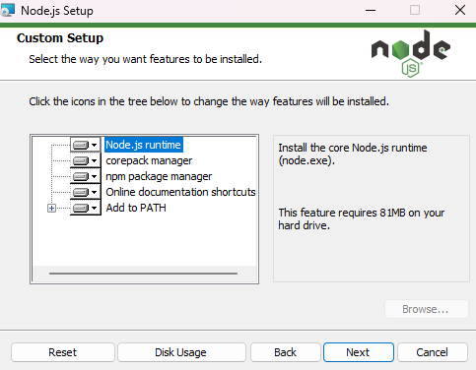
Do not click on the check box and immediately click on the next button, you do not need to C/C++ npm
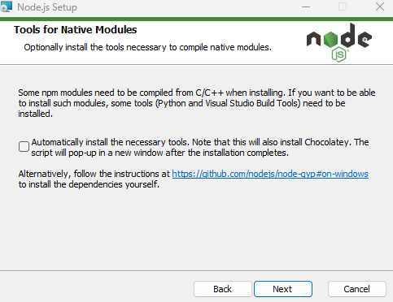
The program will now install and once complete click on the finish button

Git: Git Download

Once you click on the link above you will be taken to git’s website to download the software, select from the top section your operating system.
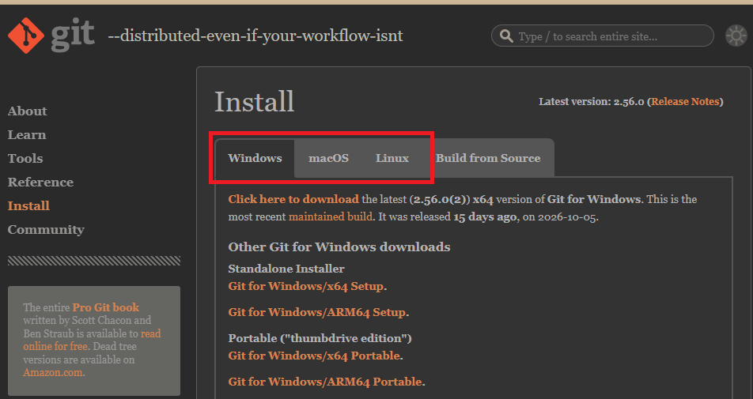
Once selected click on the git for windows/x64 Setup
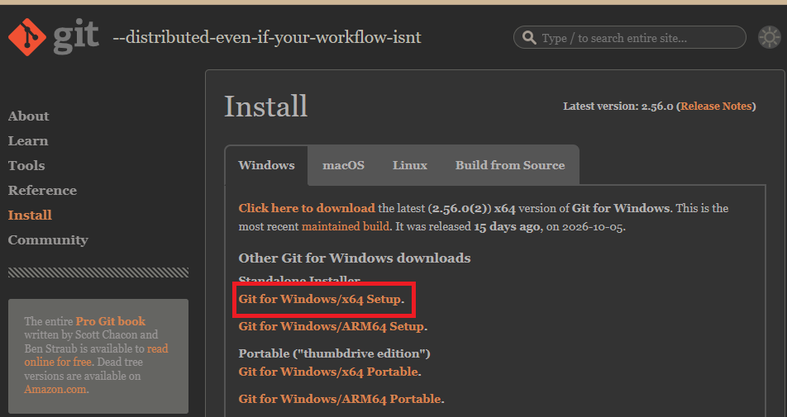

Once you have downloaded the installer, execute it and click on the next button

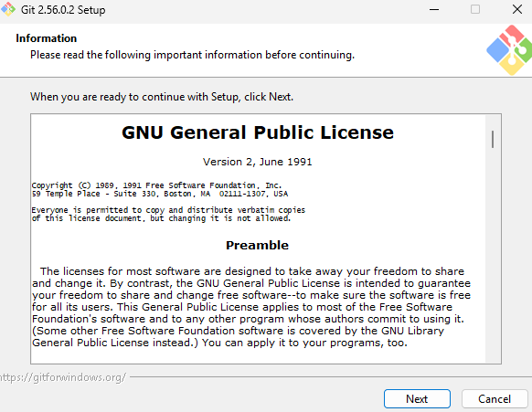
Next you will choose the location where you would prefer the git files to be installed to. Once selected click on the next button
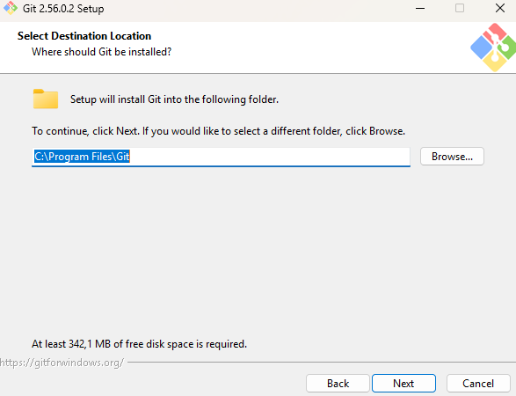
In the next page you will select which components should be installed, the default ones can be chosen
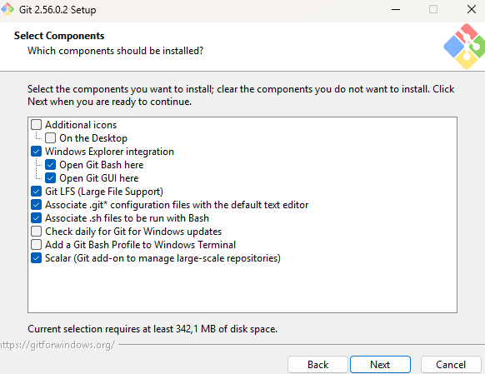
On the next page you can choose whether or not the system creates a shortcut for you. Tick the box if you don't want it to add one and then click next or just click next if you would like one
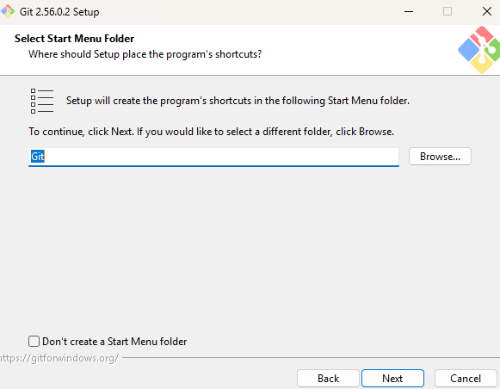
Next you will choose the text editor, the default one works without issues
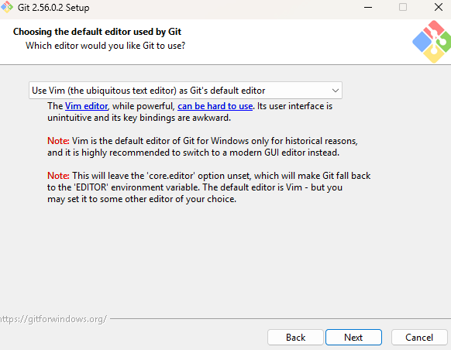
Next you will choose a default name for that git will assign to repositories that you create, the default choice is correct. Click next once you have decided
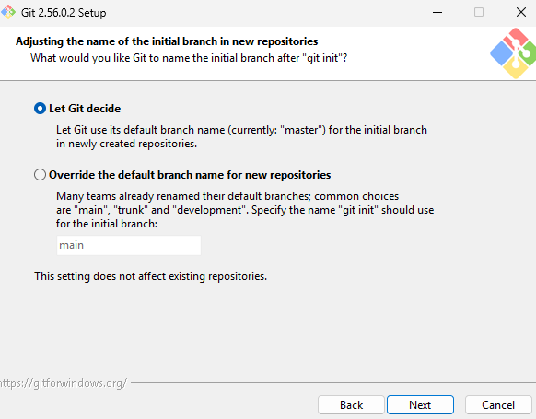
Next we choose the recommended option and click next
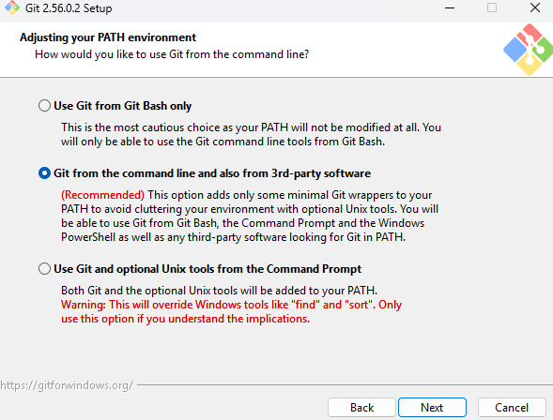
In the next page we will choose the bundled SSH executable and click next
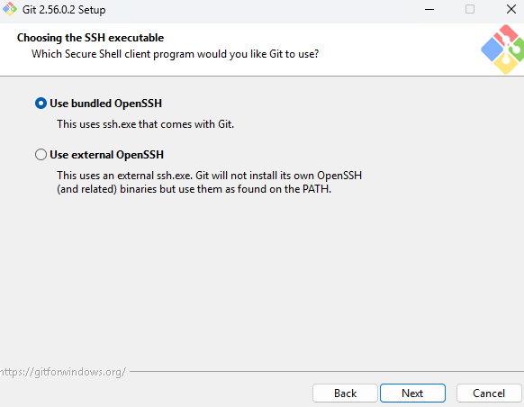
Next we choose use native windows secure channel library
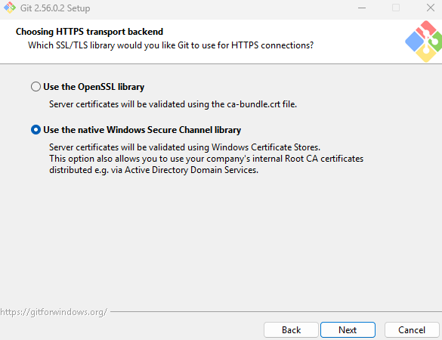

Next we choose the line ending we prefer for git to read
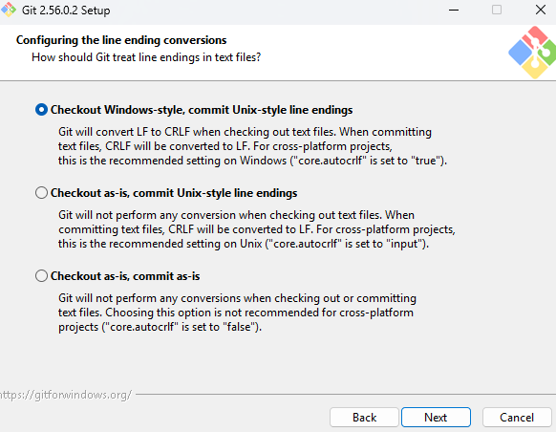
We now choose preferred terminal emulator
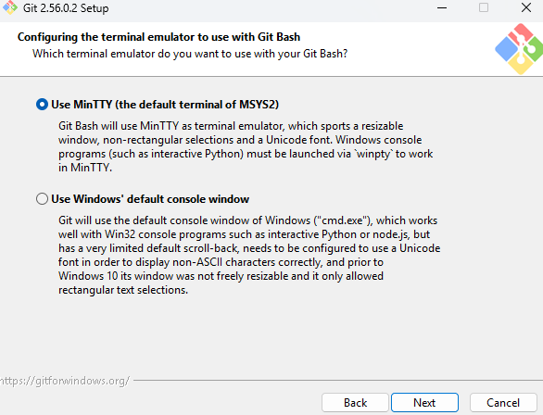

We now select how git operates the git pull command
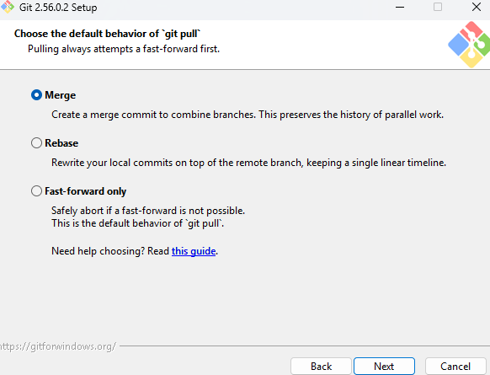
We now select help with credential manager
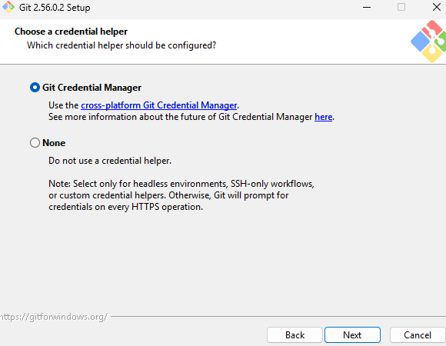
WE enable file system caching and then click the install button, once the system has completed its installation you can click finish
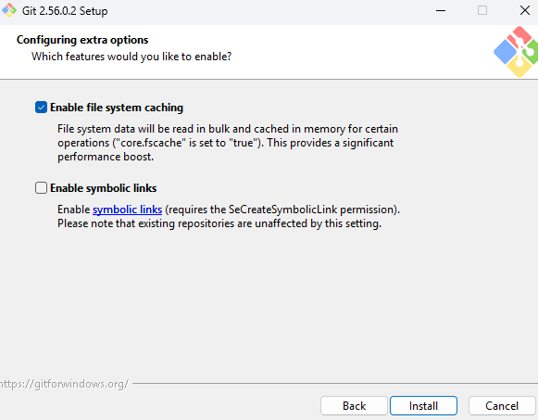

Visual Code: Visual Download

Once you have clicked on the above link, click on the download button for your devices operating system
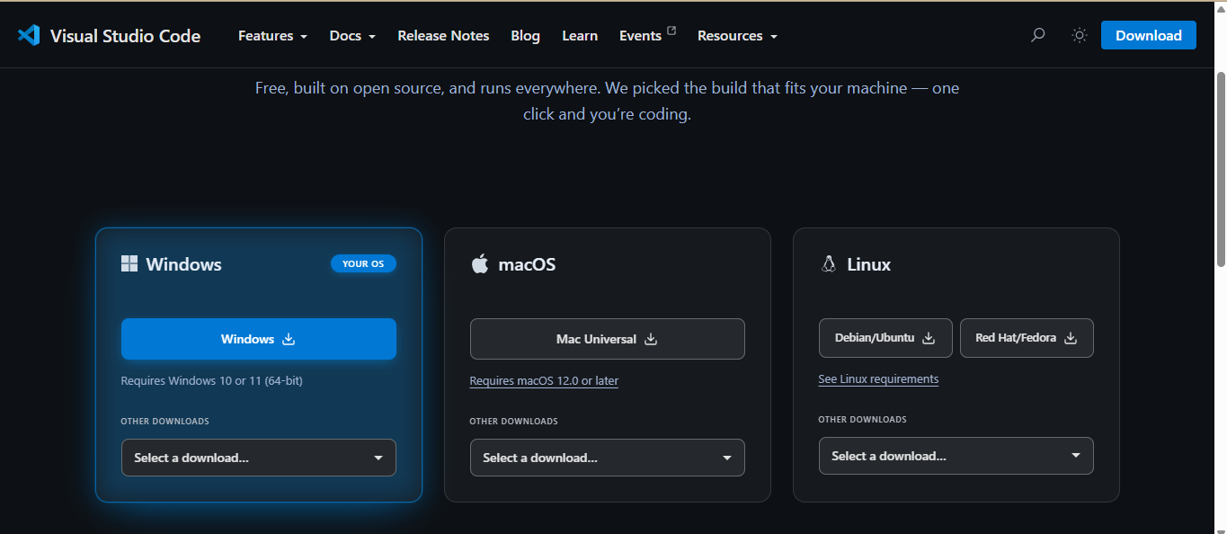

Once you have downloaded the installer, execute it, accept the license agreement and click on next
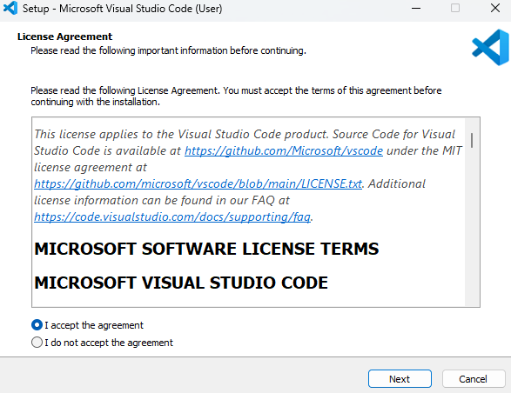
Next you will choose where to install the app, click on next once you have chosen a location
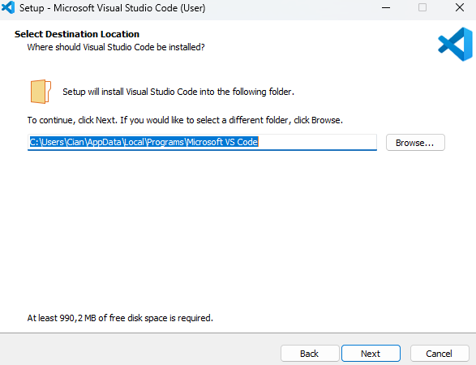
Choose if the app will add an icon to the start menu, tick the check box if you do not want it to and click on next
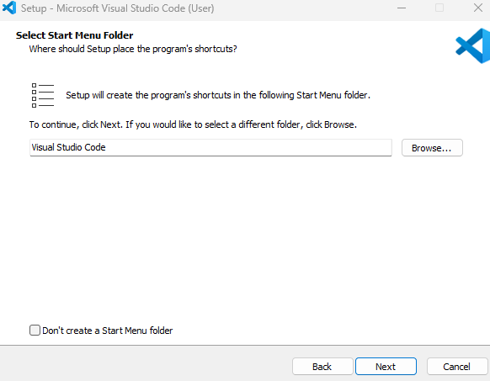
Configure the additional tasks visual studio code must perform, the default ones are the only ones needed.
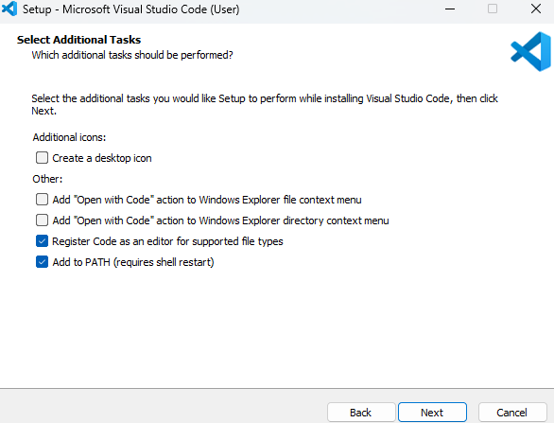
Click the install button and wait for the application to complete its installation

Configure PHP
Before the system can be installed, you must configure the php.ini file to do this navigate to this->”The drive you installed all of the software on”-> then click on your Xxamp folder. In this case we installed all the software on the C: drive
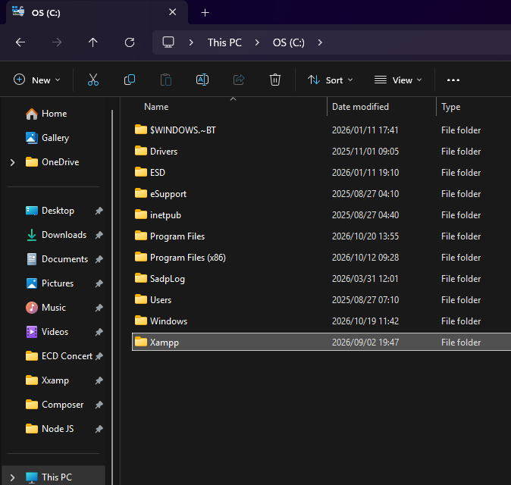
Inside this folder find a folder called php
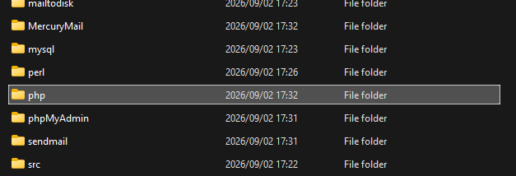
In this folder find the file named php with the ini source file extension
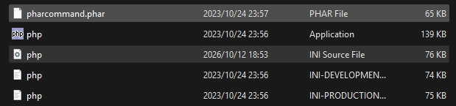
Right click on this file and open it with visual studio code

Once open in visual studio code, press control+f to open the search tool and then you will search for the following lines of codes and remove the semi-colon from the front of the line. The first line will have pictures to guide you.

extension=fileinfo

Copy the above text into the box created by ctrl+f
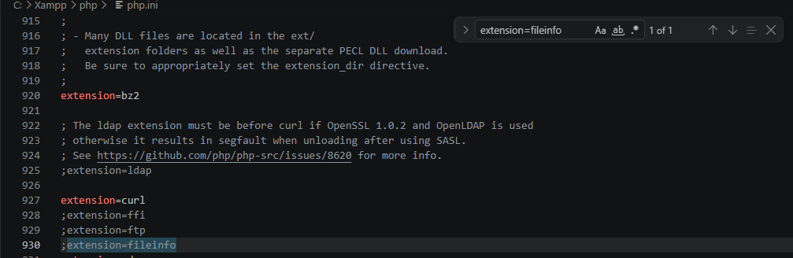
Some of the extensions will already have their semi-colon removed, if they haven't, remove the semi-colon and you will see that the piece of code now is no longer greyed out. You do the same for the rest of the extensions

extension=pdo_sqlite
extension=sqlite3
extension=gd
extension=mbstring
extension=openssl
extension=curl
extension=zip

Once you have completed all the extensions you must then save the file before closing it

Cloning the Project
Navigate through your file explorer and locate where you would prefer to install the project, in this example we have installed it within document. Once you have found the location, create a folder and name the it Hermes platform
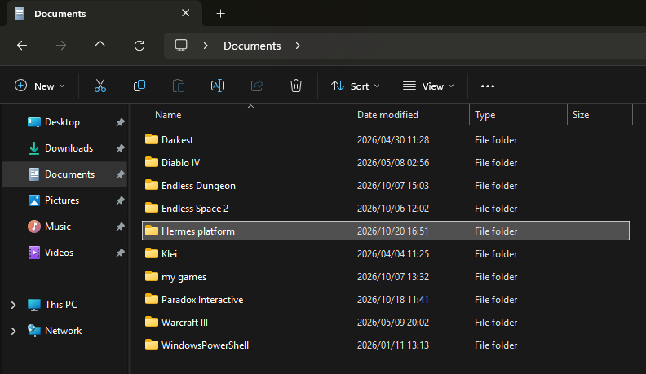
Enter the empty folder right click on the screen witch will bring up a menu and click on open gitbash here
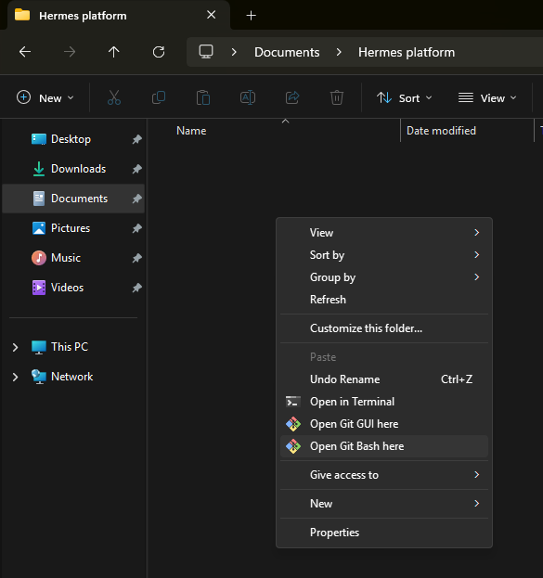
This will now open a new form that looks similar to a command prompt, from within this command prompt execute the following commands one after the other
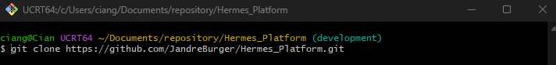
Then execute the command
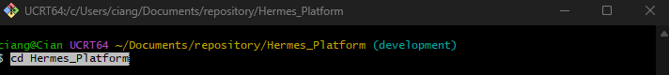
The execute the command
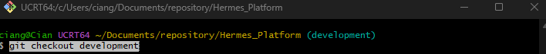

Once you have executed all the commands the Hermes Platform folder will not be filled with files
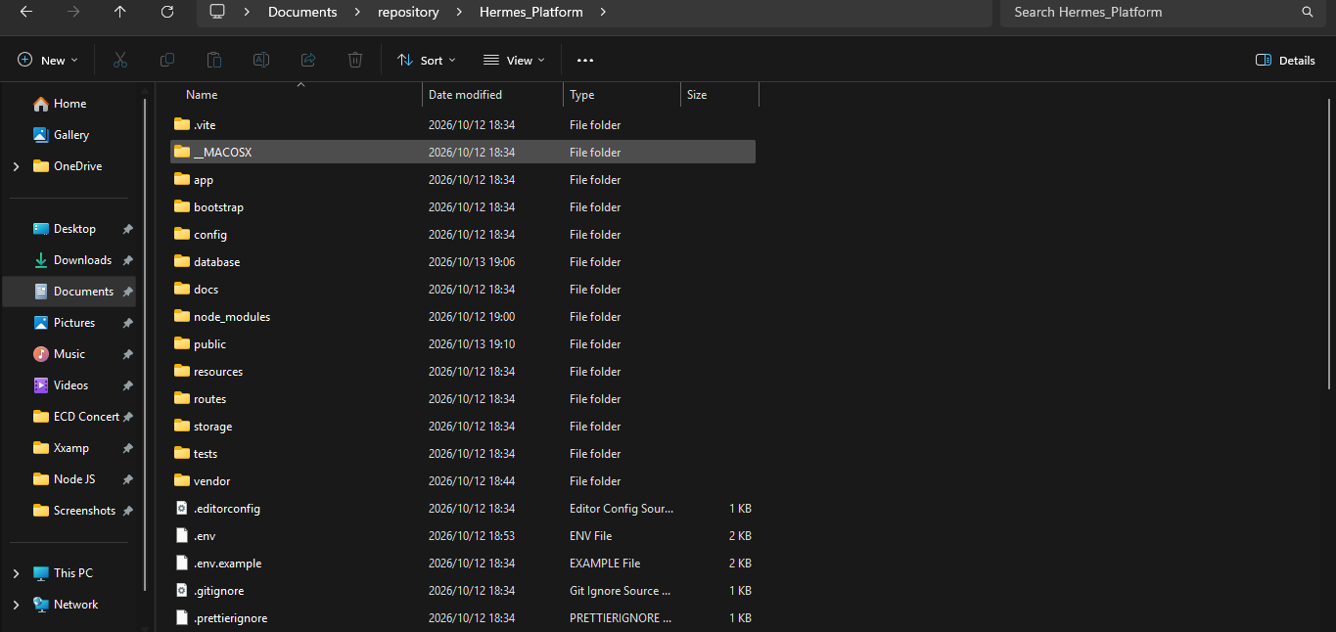

Install Dependencies
Once the folder has been filled, run this command to connect composer
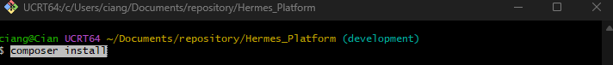
Afterwards run this command to connect node.js and npm
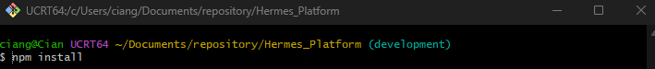

Configure the Environment
Run the following three commands
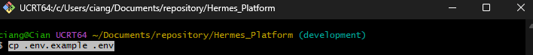
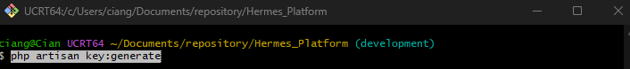

Build and seed the database
To seed the database with dummy data for testing purposes use the following command
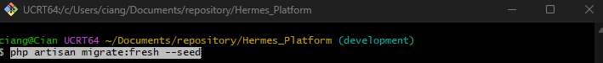

Start the App
You have now completed all the steps for installing and setting up the Hermes Platform system. To access the system you must now run two terminals simultaneously. You must navigate back to the Hermes Platform folder and right click to open two separate git bash
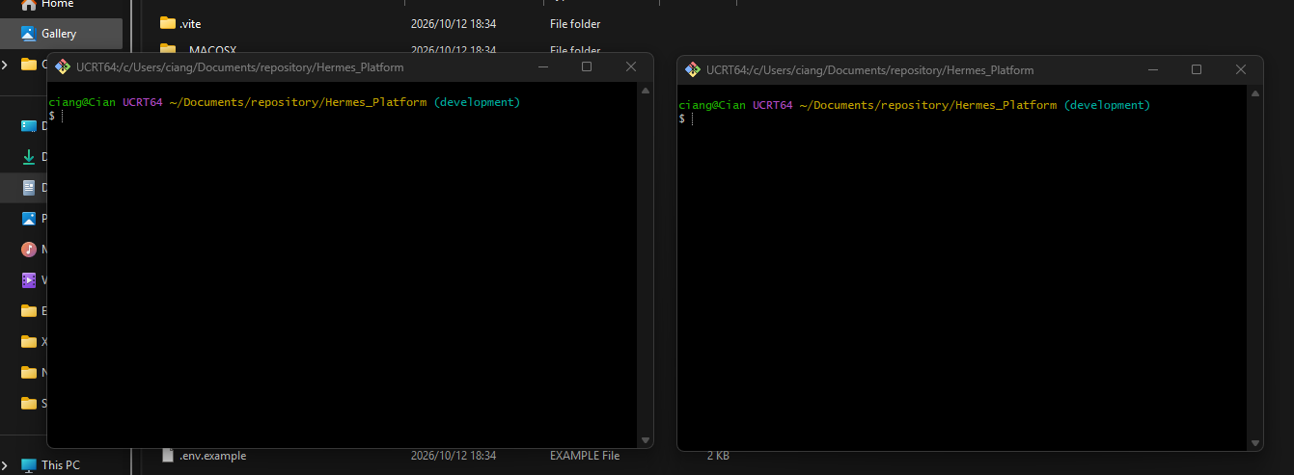
In the first terminal you must execute the command
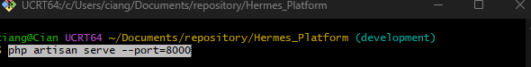
In the second terminal you must execute the command
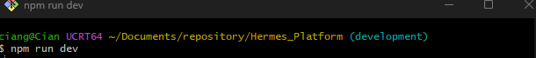
In your second terminal you should now be looking at the image below
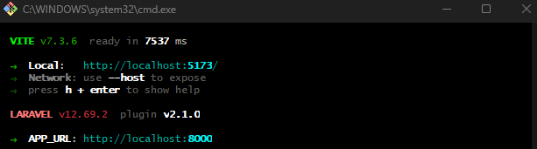
In your first terminal you should now see
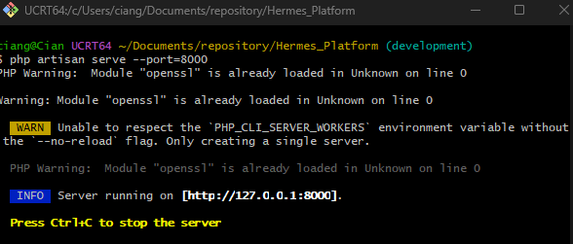
In your first terminal you will now be able to copy an IP address
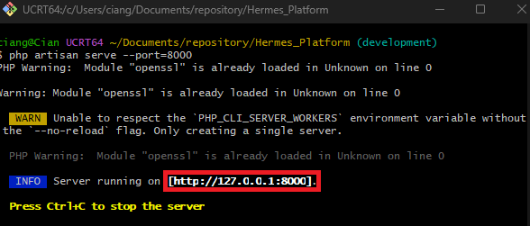
Your final step is to highlight the IP address and right click and then click copy, do not use short cuts and Ctrl+C will stop the program. From this point you may now use the User Guide.

